CHAPTER 1

**INTRODUCTION**

Agriculture is the largest source of livelihoods in India. Seventy percent (70%) of its rural households still primarily depend on agriculture for their livelihood [1]. The efficient growth of crops is primarily dependant on the soil fertility. Soil nutrients are the major factor for soil fertility which helps for the efficient plant growth. Soil nutrient has become a necessary resource to be upgrade further over the past decade due to rapid growth in usage of chemical fertilizer and pesticide, disposal of waste product from domestic and industrial sector on land.

Nowadays soil resource is facing damage due to lack of amount of soil nutrient present in the soil. Due to this problem of soil nutrient degradation, farmers are unable to produce required amount of crops in efficient way. Knowing fertility or nutrient status of soils can be useful for farmers to manage their soil’s fertility by applying different methods on soil and farmer can grow crop according to fertility of their soil which is suitable for particular fertility level.

Soil quality is equally important as that of crop production. Topographic maps, aerial photographs, remote sensing data provide useful tool for geomorphic analysis of region and help in the soil mapping. Therefore, on the basis of GPS-GIS system and remote sensing, detailed soil fertility evaluation can be made to make the best use of soil for crop production [2, 3]. GPS-GIS are advanced tool for studying on site specific nutrient management which can be efficient use for monitoring soil fertility status of a region, and it is useful for ensuring balanced fertilization to crop [2]. Geographic Information System (GIS) is a computer-based tool for mapping and analysing feature events on earth. GIS technology integrates common database operations, such as query and statistical analysis, with maps. GIS manages location-based information and provide tools for display and analysis of various statistics, including population characteristics, economic development opportunities, and vegetation types. GIS allows us to link databases and maps to create dynamic displays. Additionally, it provides tools to visualize, query, and overlay those databases in ways not possible with traditional spreadsheets. These abilities distinguish GIS from other information systems, and make it valuable to a wide range of public and private enterprises for explaining events, predicting outcomes, and planning strategies. There are many types of GIS software, some are open source and some are licensed. Among all GIS software, most commonly used software are Arc GIS, QGIS, SAGA GIS, Grass GIS, GeoMedia, MapInfo etc. GPS is location system administrated by US military which helps to determine the exact position of an object on the earth surface in term of geographical coordinate [3]. Remote sensing is the art and science of making measurements of the earth using sensors on airplanes or satellites. These sensors collect data in the form of images and provide specialized capabilities for manipulating, analysing, and visualizing those images. Remote sensed imagery is integrated within a GIS.

The fertility of soil plays important role in increasing crop production in the soil. It comprises not only in supply nutrient but also in their efficient management. For mapping of soil fertility, soil tested data generated by the soil testing laboratory will be helpful.

* 1. **Soil Taxonomy**

USDA soil taxonomy (ST) developed by United States Department of Agriculture and the National Cooperative Soil Survey provides an elaborate classification of soil types according to several parameters (most commonly their properties) and in several levels: Order, Suborder, Great Group, Subgroup, Family, and Series. The classification was originally developed by Guy Donald Smith, former director of the U.S. Department of Agriculture's soil survey investigations. [4]

A taxonomy is an arrangement in a systematic manner; the USDA soil taxonomy has six levels of classification. They are, from most general to specific: order, suborder, great group, subgroup, family and series. Soil properties that can be measured quantitatively are used in this classification system – they include: depth, moisture, temperature, texture, structure, cation exchange capacity, base saturation, clay mineralogy, organic matter content and salt content. There are 12 soil orders (the top hierarchical level) in soil taxonomy. The names of the orders end with the suffix -sol. The criteria for the different soil orders include properties that reflect major differences in the genesis of soils. The orders are:

1. **Alfisol** – soils with aluminium and iron. They have horizons of clay accumulation, and form where there is enough moisture and warmth for at least three months of plant growth. They constitute 10% of soils worldwide.
2. **Andisol** – volcanic ash soils. They are young and very fertile. They cover 1% of the world's ice-free surface.
3. **Aridisol** – dry soils forming under desert conditions which have fewer than 90 consecutive days of moisture during the growing season and are nonleached. They include nearly 12% of soils on Earth. Soil formation is slow, and accumulated organic matter is scarce. They may have subsurface zones of caliche or duripan. Many aridisols have well-developed Bt horizons showing clay movement from past periods of greater moisture.
4. **Entisol** – recently formed soils that lack well-developed horizons. Commonly found on unconsolidated river and beach sediments of sand and clay or volcanic ash, some have an A horizon on top of bedrock. They are 18% of soils worldwide.
5. **Gelisol** – permafrost soils with permafrost within two metres of the surface or gelic materials and permafrost within one metre. They constitute 9% of soils worldwide.
6. **Histosol** – organic soils, formerly called bog soils, are 1% of soils worldwide.
7. **Inceptisol** – young soils. They have subsurface horizon formation but show little eluviation and illuviation. They constitute 15% of soils worldwide.
8. **Mollisol** – soft, deep, dark fertile soil formed in grasslands and some hardwood forests with very thick A horizon. They are 7% of soils worldwide.
9. **Oxisol** – are heavily weathered, are rich in iron and aluminum oxides (sesquioxides) or kaolin but low in silica. They have only trace nutrients due to heavy tropical rainfall and high temperatures and low CEC of the remaining clays. They are 8% of soils worldwide.
10. **Spodosol** – acid soils with organic colloid layer complexed with iron and aluminium leached from a layer above. They are typical soils of coniferous and deciduous forests in cooler climates. They constitute 4% of soils worldwide.
11. **Ultisol** – acid soils in the humid tropics and subtropics, which are depleted in calcium, magnesium and potassium (important plant nutrients). They are highly weathered, but not as weathered as Oxisols. They make up 8% of the soil worldwide.
12. **Vertisol** – inverted soils. They are clay-rich and tend to swell when wet and shrink upon drying, often forming deep cracks into which surface layers can fall. They are difficult to farm or to construct roads and buildings due to their high expansion rate. They constitute 2% of soils worldwide.
    1. **Soil Fertility**

Soil fertility refers to the ability of a soil to sustain agricultural plant growth, i.e. to provide plant Nutrient and result in sustained and consistent yields of high quality crop. It is measured according to the amount of soil fertility measurement parameters present in the particular soil [5].

* + 1. **Types of Soil Fertility**

There are mainly two type of fertility, they are:

1. **Inherent or Natural Fertility**

The soil, as a nature of them, contains some nutrients which is known as ‘inherent fertility’. Among the plant nutrients, nitrogen, phosphorus and potassium is essential for the normal growth and yield of crop. Indian soil contains 0.3 to 0.2 per cent nitrogen, 0.03 to 0.3 per cent phosphorus and 0.4 to 0.5 per cent potassium. The inherent fertility has a limiting factor from which the fertility is not decreased [5].

1. **Acquired Fertility**

The fertility developed by application of manures and fertilizers, tillage, irrigation etc. is known as ‘acquired fertility’. The acquired fertility has also a limiting factor. It is found by experiment that the yield does not increase remarkably by application of additional quantity of fertilizers. So it is necessary to apply fertilizer on the basis of nutrient content of a soil and it is estimated by soil testing [5].

**1.2.2. Losses of Plant Nutrients from the Soil**

Soil is the store house of plant nutrients. Losses of plant nutrients from the soil are the main cause of decreasing the fertility of soil. Plant nutrients are lost from the soil by the following ways [5].

1. **Removal of Plant Nutrients by Harvested Crops**

Plant absorbs nutrients from the soil and stores them in their different parts. The crops remove large quantity of nitrogen and potassium and relatively small quantity of phosphorus. Four to five per cent of total nitrogen is lost from soil per acre annually through the harvested crops. The loss can be reduced by adding farm waste materials to the soil.

1. **Removal of Plant Nutrients by Weeds**

Weeds compete with crops for mineral nutrients. Competition begins when the supply of plant nutrients falls below the requirements of both weeds and crops. Weeds by nature of them grow fast and remove the plant nutrients from the soil. This will be acute if weeding is not done as soon as weeds emerge or germinate.

1. **Losses of Nutrient by Soil Erosion**

Erosion is the physical removal of top soil by water and wind. Plant nutrient, particularly nitrogen remains on the upper layer of soil. When erosion is severe, the nutrient is lost along with soil and the fertility of soil decreases accordingly.

**(Iv) Losses of Nutrients by Leaching**

Fertilizers, both straight and mixed, are soluble in water and as such they are liable to loss by leaching in rain water or irrigation water. Leaching loss is more acute in sandy soil and bare soils. Nitrogen is mainly lost from soil by leaching.

**(V) Losses of Nutrients in Gaseous Form**

Nitrogen is generally subjected to loss in gaseous form.

**1.2.3. Factors Affecting Soil Fertility**

The factors affecting soil fertility may be of two types; i.e. – (a) Natural factor and (b) Artificial factor. The natural factors are those which influence the soil formation and the artificial factors is related to the proper use of land.factors affecting the fertility of soil are as follows [5]:

1. **Parent Materials**

The property of soil depends on the property of parent rock. If the parent rock contains more nutrient, the soil developed from rock contains more nutrient. The soil developed from calcareous rock contains more phosphorus than the soil which is developed from granite rock. The soil developed from acid igneous rock (i.e. quartz) and basic igneous rock (i.e. norite and dolerite etc.) become sandy and clayey in nature respectively.

1. **Climate and Vegetation**

Plant kingdom is closely related with climate. Rainfall and temperature has an effect on soil fertility. In heavy rainfall areas, the nutrients are lost by leaching. As a result of which the fertility of that soil becomes low. Besides these, the upper layer is eroded which decreases the soil fertility. Organic matter is oxidized in high temperature. For this, the fertility of soil in temperate region becomes low.

1. **Topography**

The fertility of soil is also dependent on the topography of soil. Leaching and erosion is most common in sloppy land. As a result of which, the fertility of that soil becomes low. On the other hand, the fertility of level and becomes more, because the nutrient of high land in soluble form deposited in the level land, especially in low land.

1. **Inherent Capacity of Soil to Supply Plant Nutrients**

The nutrient contents of a soil vary according to the nature of soil. The soil which contains much quantity of nutrient becomes more fertile. In an experiment in central farm, Coimbatore, it was found that the garden soil of nine inches depth contains 1400 lb (630 kg) potassium per acre. So the fertility of soil depends on the inherent capacity of soil.

1. **Physical Condition of Soil**

Aeration and movement of water is good in the soil containing adequate amount of organic matter and this type of suitable condition of soil is beneficial for the growth of plant. The physical condition of soil should be suitable for the growth and development of plant. It is essential for proper supply of oxygen in the soil. Improper supply of oxygen is unsuitable for the growth of plants as well as for the proper function of soil organism.

As a result of which, organic matter does not decompose properly and the nutrients of organic matter does not transform in available form of the plant. Suitable physical condition of the soil increases the water holding capacity of soil which is favorable for the growth of plant. The fertility of soil depends mostly on the texture and structure of soil.

1. **Soil Age**

The soil developed earlier losses its fertility gradually. Because the fertility of the soil decreases by the process of leaching and weathering in course of time. Besides this, cultivation of crops without manuring decreases the fertility of soil.

1. **Micro-Organism and Soil Fertility**

Various types of organism live in the soil. The soil organism brings the unavailable nutrients into the available form. Different types of bacteria, fungi and algae live in the soil. The nitrifying bacteria fix nitrogen from air. Dr. P.K. De, in an experiment showed that blue green algae fix 50 kg nitrogen per hectare in the paddy land having good amount of water.

1. **Availability of Plant Nutrients**

The nutrient of the soil must be in the available form of plant. The plant does not absorb nutrient if it is not soluble in water. Super phosphate applied in acid soil is converted into iron or aluminium phosphate which is not soluble in water. As a result, phosphate remains in the soil in unavailable form to plant.

The availability of nutrients depends mainly on the following factors:

(a) Soil aeration.

(b) Soil ph.

(c) Activity of microorganism.

1. **Soil Composition and Fertility**

The plant absorbs the nutrient from the soil. The nutrient of minerals becomes available by weathering. The soil containing more organic matter becomes more fertile. The sandy soil is less fertile, whereas loamy soil is more fertile.

1. **Organic Matter and Soil Fertility**

The fertility of soil increases if the soil contains more organic matter. Organic matter contains the plant nutrients. Besides this, organic matter improves the physical condition of soil. Decomposition of organic matter increases the nitrogen content of soil. Thus the fertility of soil increases.

1. **Soil Erosion**

Erosion is the physical removal of top soil by water and wind. As such it decreases the fertility of soil. Because the nutrients remaining in upper layer of soil is lost by erosion and the fertility of soil decreases accordingly.

1. **Cropping System**

Cultivation of same crop year after year in the same field decreases the fertility of soil. There are various types of cropping system in India such as mono-cropping, mixed cropping, relay cropping and crop rotation. Crop rotation increases the fertility of soil.

1. **Favorable Environment for Root Growth**

The suitable condition for growth of plant depends on physical, chemical and biological condition of soil. Soil contains 25 per cent water and 25 per cent air by its volume and this condition is favorable for good aeration. The bad aeration in the soil is not good for the growth of the crop.

**1.2.4. Major Parameters Needed to Measure Fertility of Soil**

Both chemical and physical properties of soil is needed for the analysis of soil fertility. Knowing soil fertility of land before growing crop is efficient for crop production. Soil fertility is the major factor for the plant growth. Different type of soil parameters is needed for the soil fertility analysis; they are [5]:

**Soil pH:**

Soil pH is a measure of the acidity and alkalinity in soils. pH levels range from 0 to 14, with 7 being neutral, below 7 acidic and above 7 alkaline. The optimal pH range for most plants is between 5.5 and 7.0.

**Nitrogen (N):**

Nitrogen is a key element for the plant growth. It is found in all plant cells, in plant it is found in proteins and hormones, and in chlorophyll. Atmosphere nitrogen is used as source of soil nitrogen.

**Phosphorus (P):**

It is the factor of soil nutrient which helps for plant to growth and provide a mechanism. For providing a plant formation.

**Potassium (K):**

The potassium is the important soil fertility nutrient.

It helps to transform the water into the plant. Potassium is an essential nutrient for plant growth. It is classified as a macronutrient because plants take up large quantities of potassium during their life cycle and growth.

**Organic Compound (OC):**

Soil organic matter comprises all living soil organisms and all the remains of previous living organisms in their various degrees of decomposition. The living organisms can be animals, plants or micro-organisms, and can range in size from small animals to single cell bacteria only a few microns long.

**Soil Moisture:**

Soil moisture is the important factor of soil fertility. The Water contained in soil is called soil moisture. The water is grasped within the soil pores. Soil water is the major component of the soil in relation to plant growth. If the moisture content of a soil is ideal for plant growth, plants can readily absorb soil water. Not all the water grasp in soil, is available to plants. Much of water remains in the soil as a thin film.

**Sulphur(S):**

Sulfur also acts as a soil conditioner and helps reduce the sodium content of soils. Sulfur born in fertilizer assists in seed oil production, but the mineral can accumulate in sandy or overworked soil layers.

It is typically considered a secondary macronutrient (along with calcium and magnesium), but is essential for maximum crop yield and quality. Sulfur is often ranked immediately behind nitrogen, phosphorus, and potassium in terms of quantity taken up.

**Zinc (Zn):**

Most zinc in soils is held in unavailable forms, such as metallic oxides and other mineral complexes Plant-available zinc exists as the cation Zn in soil solution. Zinc concentration in soil is affected by the composition and weathering of the parent material, soil organic matter level, soil pH, and concentrations of other nutrients. Course-textured and highly weathered soils generally have lower concentrations of available zinc.

**Iron (Fe):**

Iron is the fourth most abundant element found in soil though it is largely present in forms that cannot be taken up by plants. Iron, in small amounts, is essential for healthy plant growth and is classed as a micronutrient. It is important for the development and function of chlorophyll and a range of enzymes and proteins.

**Copper (Cu):**

Copper (Cu) is one of eight essential plant micronutrients. Copper is required for many enzymatic activities in plants and for chlorophyll and seed production. Deficiency of copper can lead to increased susceptibility to diseases like fergot, which can cause significant yield loss in small grains. Most Minnesota soils supply adequate amounts of copper for crop production.

**Manganese (Mn):**

Magnesium is an essential plant nutrient. It has a wide range of key roles in many plant functions. One of the magnesium's well-known roles is in the photosynthesis process, as it is a building block of the Chlorophyll, which makes leaves appear green. Magnesium deficiency might be a significant limiting factor in crop production.

**Boron (B):**

Boron (B) is a micronutrient that is essential for cell wall formation and rapid growing points within the plant, such as reproductive structures. Interestingly, while higher plants require B, animals, fungi and microorganisms do not need this nutrient.

**1.2.5. Parker’s Nutrient Index**

In order to compare the levels of soil fertility of one area with those of another it is necessary to obtain a single value for each nutrient. Here the nutrient index introduced by Parker et. al. 7 is useful. The percentage of samples in each of the three classes, low, medium and high is multiplied by 1, 2 and 3 respectively. The sum of the figures thus obtained is divided by Total Number of Samples using following equation [11]:

E.q. 1.1.

Where,

NL – Number of samples falling in Low

NM – Number of samples falling in Medium

NH – Number of samples falling in High

NT – Total number of samples

Standard value for the measurement of NPK (Nitrogen, Phosphorous and Potassium) values are given in the Table 1.1 suggested by Parker et al., 1951.

**Table 1.1.** Rating Chart for Soil Test Values and their Nutrient Indices [11]

|  |  |  |  |  |
| --- | --- | --- | --- | --- |
| **Soil Property** | **Unit** | **Range** | | |
| Soil pH | pH unit | <6.o(Acidic) | 6.1-8.0(Neutral) | >8.0(Alkaline) |
| Electrical Conductivity | dS/m | <1.0(Normal) | 1.0-2.0(Critical) | >2.0(Injurious) |
| Organic Carbon | % | <0.5(Low) | 0.5-0.75(Medium) | >0.75(High) |
| Available Nitrogen(N) | kg/ha | <280(Low) | 280-560(Medium) | >560(High) |
| Available Phosphorous(P2O5) | kg/ha | <10(Low) | 10-25(Medium) | >25(High) |
| Available Potassium(K2O) | kg/ha | <110(Low) | 110-280(Medium) | >280(High) |
| Available Sulphur(S) | Ppm | <10(Low) | 10-30(Medium) | >30(High) |
| Exchangeable Calcium(Ca) | meq/100g | <1.5(Low) | 1.5-4.5(Medium) | >4.5(High) |
| Exchangeable Mg | meq/100g | <1.5(Low) | 1.5-4.5(Medium) | >4.5(High) |
| Available Zinc(Zn) | Ppm | <0.6(Low) | 0.6-1.0(Medium) | >1.0(High) |
| Available Manganese (Mn) | Ppm | <2.0(Low) | 2-3(Medium) | >3.0(High) |
| Available Iron(Fe) | Ppm | <0.2(Low) | 0.2-0.6(Medium) | >0.6(High) |
| Available Copper(Cu) | Ppm | <4.5(Low) | 4.5-5.5(Medium) | >5.5(High) |
| **Nutrient Index** | **Index** | **I** | **II** | **III** |

|  |  |  |
| --- | --- | --- |
| **Nutrient Index** | **Range** | **Remarks** |
| I | Below 1.67 | Low |
| II | 1.67 - 2.33 | Medium |
| III | Above 2.33 | High |

**Table 1.2.** Nutrient index with range and remarks [11].

* 1. **Map**

A map is a visual representation of an entire area or a part of an area, typically represented on a flat surface. The work of a map is to illustrate specific and detailed features of a particular area, most frequently used to illustrate geography [6]. There are many kinds of maps; static, two-dimensional, three-dimensional, dynamic and even interactive. Maps attempt to represent various things, like political boundaries, physical features, roads, topography, population, climates, natural resources and economic activities.

* + 1. **Types of Map**

1. **Political Maps**

A political map does not show topographic features like mountains. It focuses solely on the state and national boundaries of a place. They also include the locations of cities large and small, depending on the detail of the map [6].

1. **Physical Maps**

A physical map is one that documents landscape features of a place. They generally show things like mountains, rivers, and lakes. Bodies of water are commonly shown in blue. Mountains and elevation changes are usually shown with different colors and shades to show relief. Normally on physical maps, green shows lower elevations while browns show high elevations [6].

1. **Topographic Maps**

A topographic map is similar to a physical map in that it shows different physical landscape features. Unlike physical maps, this type of map uses contour lines instead of colors to show changes in the landscape. Contour lines on topographic maps are normally spaced at regular intervals to show elevation changes (e.g. each line represents a 100-foot (30m) elevation change) and when lines are close together the terrain is steep [6].

1. **Climate Maps**

A climate map shows information about the climate of an area. They can show things like the specific climatic zones of an area based on the temperature, the amount of snow an area receives or the average number of cloudy days. These maps normally use colors to show different climatic areas [6].

1. **Economic or Resource Maps**

An economic or resource map shows the specific types of economic activity or natural resources present in an area through the use of different symbols or colors depending on what is being shown on the map [6].

1. **Road Maps**

A roadmap is one of the most widely used map types. These maps show major and minor highways and roads (depending on detail), as well as things like airports, city locations and points of interest such as parks, campgrounds, and monuments. Major highways on a roadmap are generally shown in red and larger than other roads, while minor roads are a lighter color and a narrower line [6].

1. **Thematic Maps**

A thematic map is a map that emphasizes a particular theme or a special topic such as the average distribution of rainfall in an area. They are different from general reference maps because they do not just show natural features like rivers, cities, political subdivisions and highways. Instead, if these items are on a thematic map, they are simply used as reference points to enhance one's understanding of the map's theme and purpose.

Normally, however, all thematic maps use maps with coastlines, city locations and political boundaries as their base maps. The map's specific theme is then layered onto this base map via different mapping programs and technologies like a geographic information system (GIS) [6].

* + 1. **Cartography**

The study and practice of the many facets of maps and map making is called Cartography. It can be described as the art and science of map making. Apart from designing and producing maps, cartography includes studying the history of maps, printing, distributing and selling them, collecting, conserving and curating them in map libraries. The variety of maps available goes well beyond road and topographic maps, it incorporates military charts, statistical, geological, tourist and travel maps, weather and climate maps, general and specialist atlases, cartograms, transport network diagrams etc. Map for computer and internet use have recently grown in importance and Geographical Information Systems (GIS) have a digital map at their core. Good Cartography is important because a well-designed map communicates better than a badly designed one. The quality of each map varies widely [6].

* + 1. **Uses of Map**

A map is useful for both a layman and an intelligent person, as maps contain loads of information. It is up to an individual how he makes use of it. Maps are generally used for:

1. Analysis
2. Confirmation
3. Communication
4. Decoration
5. Collection
6. Investment
7. Exploration
8. Hypothesis Stimulation
9. Navigation
10. Control & Planning
11. Map Reading
12. Storage of Information
13. Historical perspective

**1.3.4. Scale of Map**

As a map has to represent a portion of earth's surface accurately, each map has to have a "scale" which indicates the relation between the distance on the map and the actual distance on the land. The map scale is typically shown in the legend box of a map, along with other symbols that provides useful information about the map.

A ratio or representative fraction specifies how many units on land is equal tone unit on the map. For example, a map showing a scale of 1/ 100000 or 1:100000, tells us that one centimeter on the map is equal to 100000 centimeters i.e. 1 kilometer on the Land. The ratio is always mentioned in the map, such as "one centimeter equals one kilometer" or "one inch equals ten miles".

A graphic scale also known as the bar scale is a line that specifies the distance in kilometers or miles as they show on a map; even as the map is enlarged or reduced in size the line has an advantage of remaining accurate.

* + 1. **Map Projection**

The method of representing the surface of a globe or any three dimensional body on a flat surface (XY coordinate system) is known as projection. Map projection is important for creating maps. The basic problem in any map projection is that there is always some distortion. It could be in distance, shape, area or direction. Map projections can be constructing to conserve one or more of these properties that are area, direction, shape, scale, distance and bearing, but not all of them together. Every projection gives and takes basic metric properties in dissimilar ways. There are different types of map projection used to represent the Earth's surface.

Projections are chosen based on the needs of the map or data analysis and on the area of the world. Projections are useful for a limited set of purposes or scales. Finally, projections are based on local needs and standards [6].

* + 1. **Understanding or reading a map**

The symbols, directions, lines and legend all require some understanding before you can start reading a map effectively. A wide variety of maps are available for a different use. For example, road maps, tourist maps, local maps etc. so decide your purpose of use and pick the right map.

1. **Compass reading**

Most maps have north drawn at the top, therefore west is left, and east is right and south is base of the map. This helps us to rotate the map until it's facing the actual directions wherever you're positioned. The compass may be depicted as a compass rose or a cross-like shape. If nothing is mentioned, the top of the map is presumed as north.

1. **Scale of the map**

Maps are made in scales that vary in size from map to map. You can find the scale in the form of a ratio, placed on the side or bottom of the map. It will show something like 1:100,000, which indicates that 1 unit on the map is the equal to 100,000 units in real life.

1. **Latitude and Longitude**

The latitude is the distance in degrees from north or south of the equator. The longitude is the distance in degrees east or west of the Greenwich Meridian Line. Each degree is separated into 60 minutes, each minute representing a nautical mile (or 1.15 land miles/1.85km). Therefore, one degree is the equal to 60 nautical miles or 69 land miles/111km. The latitude and longitude is represented by the numbers on the side and top and bottom of the map. Where these two cross at your location, that site is your actual position. These are often used when there are no landmarks or roads to find out a location.

1. **Contour lines**

These lines represent how high or flat the land is on the map. Each line signifies an average height above sea level. When these lines are close together, that means the gradient is steep. When the lines are further apart, the gradient is flatter.

1. **Legend or Key**

Maps denote particular symbols for particular items of interest. Most maps have them on the map itself and since the source of the map doesn't essentially conform to any standard, one should always look for the legend or key first. General legend or key that maps follow:

1. Lines in different sizes, colors, unbroken or broken depict roads, lanes and freeways.
2. Mountains are shown as white or brown.
3. Rivers, lakes, oceans and other water bodies are shown in blue.
4. Forests, parks or large area of greenery and land areas like parks, golf courses, etc are shown in green.
5. Buildings are shown in gray or black.

**1.3.7. Tools to Create a Map**

There are lots of tools for map-making in the market, they are:

1. **GIS Soft wares**

GIS Soft wares are used for creating maps, compiling data and analyzing mapped information, sharing geographic information, using maps and information in a variety of applications and organizing the information database. Some mostly used open source GIS Soft Wares are:

1. GRASS GIS – Originally developed by the U.S. Army Corps of Engineers: a complete GIS.
2. QGIS (previously known as Quantum GIS) – Runs on Linux, Unix, Mac OS X and Windows.
3. SAGA GIS (System for Automated Geoscientific Analysis) –- A hybrid GIS software. Has a unique Application Programming Interface (API) and a fast-growing set of geoscientific methods, bundled in exchangeable Module Libraries.
4. **Adobe Illustrator**

Adobe Illustrator is graphics design software, developed by Adobe Systems. It is one of the premier vector-drawing software for creating graphics. It is available on both Windows and Mac Operating Systems.

1. **MaPublisher**

MaPublisher is a plug-in for Adobe Illustrator that connects the gap between Geographic Information Systems and high end graphics for high quality creation, printing and publishing of maps.

1. **MapInfo**

MapInfo is a powerful mapping tool, now called Pitney Bowes Software it is designed to easily picture the associations between the data and geography

* 1. **Geographic Information System (GIS)**

For the analysing and mapping the data collected from given sources, a computer-based tool can be used called a Geographic Information System (GIS). Geographic Information System (GIS) is a computer-based tool for mapping and analysing feature events on earth as shown in fig.1.1. GIS technology integrates common database operations, such as query and statistical analysis, with maps. GIS manages location-based information and provide tools for display and analysis of various statistics, including population characteristics, economic development opportunities, and vegetation types. GIS allows you to link databases and maps to create dynamic displays. Additionally, it provides tools to visualize, query, and overlay those databases in ways not possible with traditional spreadsheets. These abilities distinguish GIS from other information systems, and make it valuable to a wide range of public and private enterprises for explaining events, predicting outcomes, and planning strategies [3]. There are many GIS soft wares, some are open source and some are licensed. Among all GIS software, most commonly used software are Arc GIS, QGIS, SAGA GIS, Grass GIS, GeoMedia, MapInfo etc.

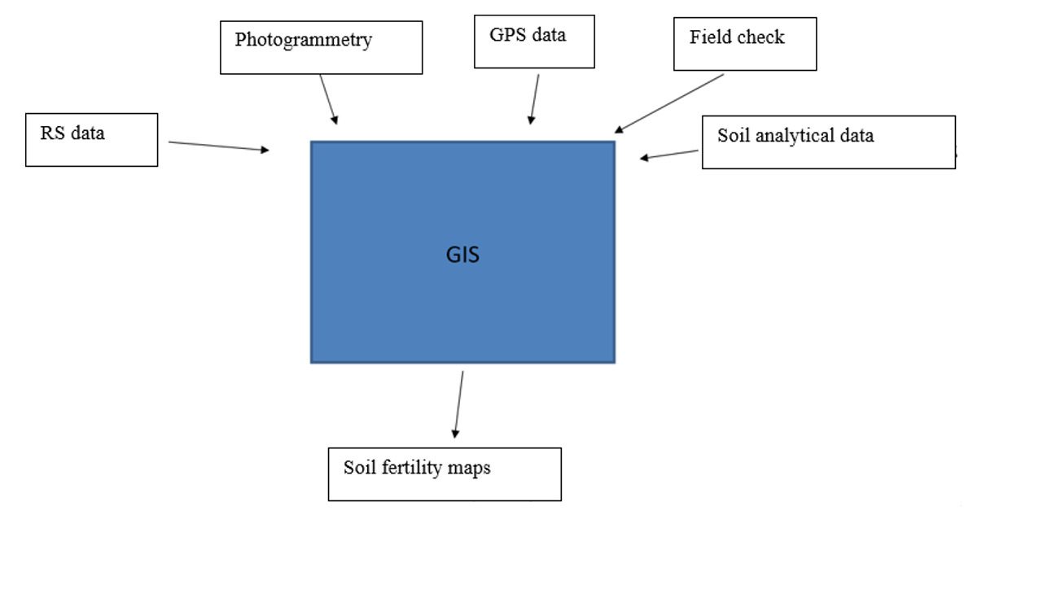

**Fig 1.1.** Working of GIS

**1.4.1. GIS Data Models**

Data models are conceptual models of the real world. These describe us the representation and storage of the geographic data. The data models used in GIS are described below [6]:

1. **Vector Data Model**

The vector data model is closely linked with the discrete object view. In vector data model, geographical phenomena are represented in three different forms; -point, line and polygon as shown in Fig:1.2. The shape of a spatial entity is stored using two-dimensional (x, y) coordinate system.

1. **Point**: A location depicted by a single set of (x, y) coordinates at the scale of abstraction. The wells in a village, electricity poles in a town and cities in the world map are the examples of spatial features described by points.
2. **Line/Arc**: Ordered sets of (x, y) coordinate pairs arranged to form a linear feature. The curves in a linear feature are generated by increasing the density of points/vertices. The roads, rails and telephone cables are the examples of the spatial features described by lines.
3. **Polygon:** The set of (x, y) coordinate pairs enclosing a homogeneous area. The land parcels, agricultural farms and water bodies are the examples of the spatial features described by polygons.

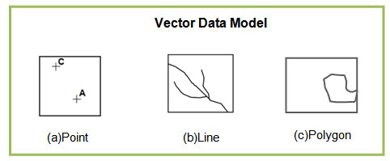

**Fig 1.2.** Types of vector data models in a diagrammatic view.

1. **Raster Data Model**

The raster data model is commonly associated with the field conceptual model. Here, geographic space is represented by array of cells or pixels (aka picture elements) which are arranged in rows and columns. Each pixel has a value that represents information. The value can be in the form of integer, floating points or alphanumeric.

A point can be represented by a single pixel in raster model. A line is a chain of spatially connected cells with the same value. Similarly, a water body in raster data is represented as a set of contiguous pixels having same value that represents a homogeneous area as shown in Fig:1.3.

|  |  |
| --- | --- |
| |  | | --- | | https://nptel.ac.in/courses/105102015/Flash/mod5-2.jpg | |
|  |
|  |
| **Fig 1.3.** Types of vector data models in a diagrammatic view. |

**1.4.2. Georeferencing**

Georeferencing means that the internal coordinate system of a map or aerial photo image can be related to a ground system of geographic coordinates. The relevant coordinate transforms are typically stored within the image file (GeoPDF and GeoTIFF are examples), though there are many possible mechanisms for implementing Georeferencing. The most visible effect of Georeferencing is that display software can show ground coordinates (such as latitude/longitude or UTM coordinates) and also measure ground distances and areas. In other words, Georeferencing means to associate something with locations in physical space. The term is commonly used in the geographic information systems field to describe the process of associating a physical map or raster image of a map with spatial locations. Georeferencing may be applied to any kind of object or structure that can be related to a geographical location, such as points of interest, roads, places, bridges, or buildings [7]. Geographic locations are most commonly represented using a coordinate reference system, which in turn can be related to a geodetic reference system such as WGS-84. Examples include establishing the correct position of an aerial photograph within a map or finding the geographical coordinates of a place name or street address.

There are various GIS tools available that can transform image data to some geographic control framework, like the commercial ArcMap, PCI Geomatics, TNTmips (Micro Images,Inc.) or ERDAS Imagine. One can georeferenced a set of points, lines, polygons, images, or 3D structures. For instance, a GPS device will record latitude and longitude coordinates for a given point of interest, effectively Georeferencing this point. A georeferenced must be a unique identifier. In other words, there must be only one location for which a georeferenced act as the reference.

Images may be encoded using special GIS file formats or be accompanied by a world file. To georeferenced an image, one first needs to establish control points, input the known geographic coordinates of these control points, choose the coordinate system and other projection parameters and then minimize residuals. Residuals are the difference between the actual coordinates of the control points and the coordinates predicted by the geographic model created using the control points. They provide a method of determining the level of accuracy of the Georeferencing process [7].

**1.4.3. Digitizing**

Digitizing is the process of converting geographic features on a paper map into digital format in GIS. The x, y coordinates of point, line and polygon features are recorded and stored as the spatial data. The feature attributes are also recorded during the digitizing process. It is the most common and labor intensive method to create a spatial database. The method is used especially when existing maps are available as the source of data. Coordinates of point features, line features and polygon features are recorded by manually pointing or tracing, using a digitizer table and cursor. The digitizing process include two methods they are [8]

1. **Manual Digitizing**

In this method, the digitizer uses a digitizing tablet (also known as a digitizer, graphics tablet, or touch tablet) to trace the points, lines and polygons of a hard-copy map. This is done using a special magnetic pen, or stylus, that feeds information into a computer to create an identical, digital map. Some tablets use a mouse-like tool, called a puck, instead of a stylus. The puck has a small window with cross-hairs which allows for greater precision and pinpointing map features

1. **Heads-up Digitizing**

This method involves scanning a map or image into a computer. The digitizer then traces the points, lines and polygons using digitizing software. This method of digitizing has been named "heads-up" digitizing because the focus of the user is up on the screen, rather than down on a digitizing tablet. It has largely replaced Manual digitizing because of its speed and accuracy. It is, however, limited to using scans of high quality maps and images. Since the tracing is done on a computer, lines can be set to snap together and polygons can be programmed to share an edge thus removing accidental sliver polygons. Heads-up digitizing also reduces or removes the need for digitizing tables.

**Digitizing tips**

• Search for the digitized data first. Digitizing is very time consuming and often the data is already digitized.

• Use multiple geographic sources when digitizing. Referencing such sources as scanned topographical maps, orthophotos, remotely sensed data, and in situ data will increase the accuracy of the digitized data.

**1.4.4. Interpolation Methods**

Interpolation is the process of using points with known values or sample points to estimate values at other unknown points. It can be used to predict unknown values for any geographic point data, such as elevation, rainfall, chemical concentrations, noise levels, and so on. One mostly used interpolation method is:

* **Kriging**

Kriging is a geostatistical interpolation technique that considers both the distance and the degree of variation between known data points when estimating values in unknown areas. A kriged estimate is a weighted linear combination of the known sample values around the point to be estimated.

Kriging procedure that generates an estimated surface from a scattered set of points with z-values. Kriging assumes that the distance or direction between sample points reflects a spatial correlation that can be used to explain variation in the surface. The Kriging tool fits a mathematical function to a specified number of points, or all points within a specified radius, to determine the output value for each location. Kriging is a multistep process; it includes exploratory statistical analysis of the data, variogram modeling, creating the surface, and (optionally) exploring a variance surface. Kriging is most appropriate when you know there is a spatially correlated distance or directional bias in the data. It is often used in soil science and geology.

The predicted values are derived from the measure of relationship in samples using sophisticated weighted average technique. It uses a search radius that can be fixed or variable. The generated cell values can exceed value range of samples, and the surface does not pass through samples [9].

**The kriging formula**

Kriging is similar to IDW in that it weights the surrounding measured values to derive a prediction for an unmeasured location. The general formula for both interpolators is formed as a weighted sum of the data:

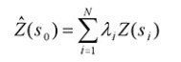

Eq. 1.2.

where:

Z(Si) = the measured value at the ith location

λi = an unknown weight for the measured value at the ith location

S0 = the prediction location

N = the number of measured values

In IDW, the weight, λi, depends solely on the distance to the prediction location. However, with the kriging method, the weights are based not only on the distance between the measured points and the prediction location but also on the overall spatial arrangement of the measured points. To use the spatial arrangement in the weights, the spatial autocorrelation must be quantified. Thus, in ordinary kriging, the weight, λi, depends on a fitted model to the measured points, the distance to the prediction location, and the spatial relationships among the measured values around the prediction location [9].

**1.4.5. Overlay**

Overlay is a GIS operation that superimposes multiple data sets (representing different themes) together for the purpose of identifying relationships between them [10]. An overlay creates a composite map by combining the geometry and attributes of the input data sets. Tools are available in most GIS software for overlaying both Vector or raster data.

1. **Overlay with Vector Data**

Feature overlays from vector data are created when one vector layer (points, lines, or polygons) is merged with one or more other vector layers covering the same area with points, lines, and/or polygons. A resultant new layer is created that combines the geometry and the attributes of the input layers [10]. An example of overlay with vector data would be taking a watershed layer and laying over it a layer of counties. The result would show which parts of each watershed are in each county.

**Polygon Overlay Functions**

Various GIS software packages offer a variety of polygon overlay tools, often with differing names. Of these, the following three are used most commonly for the widest variety of purposes:

**Intersection,** where the result includes all those polygon parts that occur in both input layers and all other parts are excluded. It is roughly analogous to AND in logic and multiplication in arithmetic.

**Union,** where the result includes all those polygon parts that occur in either A or B (or both), so is the sum of all the parts of both A and B. Different from identify in that individual layers are no longer identifiable. It is roughly analogous to OR in logic and addition in arithmetic.

**Subtract,** also known as Difference or Erase, where the result includes only those polygon parts that occur in one layer but not in another. It is roughly analogous to AND NOT in logic and subtraction in arithmetic. The remainder are used less often, and in a narrower range of applications. If a tool is not available, all of these could be derived from the first three in two or three steps.

**Symmetric Difference**, also known as Exclusive Or, which includes polygons that occur in one of the layers but not both. It can be derived as either (A union B) subtract (A intersect B), or (A subtract B) union (B subtract A). It is roughly analogous to XOR in logic.

Identity covers the extent of one of the two layers, with the geometry and attributes merged in the area where they overlap. It can be derived as (A subtract B) union (A intersect B).

**Cover,** also known as Update, is similar to union in extent, but in the area where the two layers’ overlap, only the geometry and attributes of one of the layers is retained. It is called "cover" because it looks like one layer is covering the other; it is called "update" because its most common usage is when the covering layer represents recent changes that need to replace polygons in the original layer, such as new zoning districts. It can be derived as A union (B subtract A).

**Clip** contains the same overall extent as the intersection, but only retains the geometry and attributes of one of the input layers. It is most commonly used to trim one layer by a polygon represent an area of interest for the task. It can be derived as A subtract (A subtract B). It is important to note that these functions can change the original polygons and lines into new polygons and lines and their attributes.

1. **Overlay with Raster Data**

Raster overlay involves two or more different sets of data that derive from a common grid. The separate sets of data are usually given numerical values. These values then are mathematically merged together to create a new set of values for a single output layer [10]. Raster overlay is often used to create risk surfaces, sustainability assessments, value assessments, and other procedures. An example of raster overlay would be to divide the habitat of an endangered species into a grid, and then getting data for multiple factors that have an effect on the habitat and then creating a risk surface to illustrate what sections of the habitat need protecting most.

* 1. **Remote Sensing**

Remote sensing refers to the activities of recording/observing/perceiving (sensing) objects or events at far away (remote) places. In remote sensing, the sensors are not in direct contact with the objects or events being observed. The information needs a physical carrier to travel from the objects/events to the sensors through an intervening medium. The [electromagnetic radiation](https://crisp.nus.edu.sg/~research/tutorial/em.htm) is normally used as an information carrier in remote sensing. The output of a remote sensing system is usually an [image](https://crisp.nus.edu.sg/~research/tutorial/image.htm) representing the scene being observed. A further step of [image analysis and interpretation](https://crisp.nus.edu.sg/~research/tutorial/process.htm) is required in order to extract useful information from the image. The human [visual system](https://crisp.nus.edu.sg/~research/tutorial/eye.htm) is an example of a remote sensing system in this general sense [1].

CHAPTER 2

**PLANNING**

The project is based on the mapping of soil fertility parameters of Namchi Singithang and create final map by overlying all parameters map.so we followed the model which is known as iterative waterfall model which is more advantages and useful for doing this project.

**2.1** **Iterative Waterfall Model**

In a practical software development project, the classical waterfall model is hard to use. So, Iterative waterfall model can be thought of as incorporating the necessary change to the classical waterfall model to make it usable in practical software development projects. It is almost same as the classical waterfall model expert some changes are made to increase the efficiency of the software development.

The iterative waterfall model provides feedback paths from every phase to its preceding phases, which is the main difference from the classical waterfall model.

When errors are detected at some later phase, these feedback paths allow correcting errors committed by programmers during some phase. The feedback paths allow the phase to be reworked in which errors are committed and these changes are reflected in the later phases. But, there is no feedback path to the stage – feasibility study, because once a project has been taken, does not give up the project easily. It is good to detect errors in the same phase in reduces the effort and time required to correct the errors.

**2.2 Phase Containment of Errors:**

The principle of detecting errors as close to their points of commitment as possible is known as phase containment of errors.

**2.3 Advantage of iterative waterfall model**

**a. Feedback Path:**

In the classical waterfall model, there are no feedback paths, so there is no mechanism for error correction. But in iterative waterfall model feedback path from one phase to its preceding phase allows correcting the errors that are committed and these change are reflected in the later phases.

**b. Simple:**

Iterative waterfall model is very simple to understand and use. That’s why it is one of the most widely used software development models.

Feasibility study

Requirement analysis and

Design

Analyzing and unit testing

Maintenance

Integration and System

**Fig 2.1.** Iterative Waterfall Model

**2.4 Organization Structure**

The organizational team structure that I have followed is democratic team structure the management structure and communication path in an egoless team are illustrated in fig: democratic team is that were one team member is designated team leader and occupies the position the first among team member in a democratic team because a team function best when one individual irresponsible for coordinating team activities and for making final decision in situation where consensus cannot be reached. Advantage of decision, the opportunity for team member to learn from one another, and the increased job satisfaction that accrues from good communication in an open, nonthreatening work environment.

**Fig 2.2.** Communication Path

**2.5 Preliminary Development Scheduling (Gantt chart)**

When we develop software or we do some study, it is necessary for us to do planning and the same case; we should separate each phases and should allocate time for each phase. One way to do that is through Gantt chart. It will divide each phase in certain time duration. The Gantt chart for this project i.e. **“Soil Fertility Mapping Using GIS and Remote Sensing in Namchi Singithang”** is as under.

|  |  |  |  |  |  |  |  |  |
| --- | --- | --- | --- | --- | --- | --- | --- | --- |
| Activity | Time Frame | | | | | | | |
| JAN 19 | FEB 19 | | MARCH 19 | | APRIL 19 | | MAY 19 |
| CYCLE | 1 & 2 | | 2, 3, 4, 5 & 6 | 6, 7, 8, 9 & 10 | | | 10, 11, 12, 13 & 14 | 15 & 16 |
|  |  | |  |  | | |  |  |
| Problem Identification |  | |  |  | | |  |  |
|  | |  |  | | |  |  |
| Designing |  | |  |  | | |  |  |
|  | |  |  | | |  |  |
| Implementation |  | |  |  |  | | |  |
|  | |  |  |  | | |  |
| Prototype Presentation |  | |  |  |  | |  |  |
|  | |  |  |  | |  |  |
| Analysis and Testing |  | |  |  | | |  |  |
|  | |  |  | | |  |  |
| Documentation |  | |  |  | | |  |  |
|  | |  |  | | |  |  |
| Internal Final Presentation |  | |  |  | | |  |  |
|  | |  |  | | |  |  |
| Research Paper Publication |  | |  |  | | |  |  |
|  | |  |  | | |  |  |

|  |  |
| --- | --- |
| **Proposed Activity** | **Achieved Activity** |

**Fig.2.3.** Gantt chart

CHAPTER 3

**DESIGN AND DEVELOPMENT**

For analyzing and mapping the data collected from different sources, a computer-based tool called a Geographic Information System (GIS) is used. Geographic Information System (GIS) is a computer-based tool for mapping and analyzing feature events on earth as shown in fig.3.1.

INPUT DATA

OUTPUT

GPS data

GIS

Fertility Map generation

lab tested data

RS data

Photogrammetry

**Fig.3.1.** GIS Block diagram

GIS technology integrates common database operations, such as query and statistical analysis, with maps. GIS manages location-based information and provide tools for display and analysis of various statistics, including population characteristics, economic development opportunities, and vegetation types. GIS allows to link databases and maps to create dynamic displays. Additionally, it provides tools to visualize, query, and overlay those databases in ways not possible with traditional spreadsheets. GIS software is used for the analyzing and mapping the soil nutrient distribution map of study area.

Fig 3.2. shows the general steps to be followed for the GIS processing works. We have followed these steps from analyzing our soil data to mapping the distribution of each nutrient in the study area.

STARTING THE PROBLEM

DEFINING THE STUDY AREA

ACQUIRING AND AUTOMATING DATA

BUILDING THE GEODATABASE

PROCESSING THE DATA

ANALYSIS THE DATA

VISUALIZING AND PRINTING THE RESULT

**Fig 3.2.** Steps of processing in GIS

**Study Area**

The study area (shown in fig 3.2.) bounded by the latitudes 27.1670o  North and its longitude is 88.362500 east. The total geographic area of the Namchi Singithang is 750 sq.km. Namchi Singithang is the 11 constituency of Sikkim through having a smaller area is more thickly populated. Namchi, the administrative, is a small town which is accessible from the neighboring state of west Bengal. Namchi Singithang is 98 km away from Gangtok (capital of Sikkim), the state capital. Different type of soil found in Namchi Singithang are haplum _brepts, pachic haplum brepts, type hspudolls, umbric, dystrochripts.

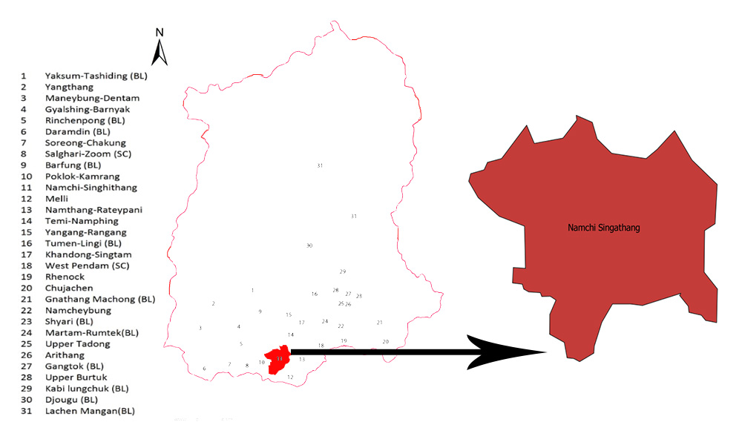

**Fig 3.4.** Study Area

For the mapping of distribution map of each nutrient of study area, we have followed following steps (shown in fig 3.4.):

Interpretation of study area map

Laboratory Soil Analysis data

Clipping of each nutrient interpolation with study area’s vector layer

Generation of final distribution map of each nutrient

Interpretation of maps for knowing distribution of each nutrient in study area

Soil sample of site

Laboratory Soil Analysis data

Interpolation of each nutrient using kriging method in QGIS

l Samples from the Site

Interpolation of each nutrient using kriging method in QGIS

Generation of distribution map of each nutrient

Reclassify each nutrient map using Parker’s Nutrient Index classes.

Outlier detection and correction of dataset

Georeferencing of study area map

Digitized

Vector layer

**Fig 3.4.** Proposed steps for the project.

These above steps are done for the making of each soil nutrient distribution map of study area. Which includes following steps:

1. **Collection of soil nutrient data:**

Soil nutrient data are collected from different sources, they are, soil health card website of Sikkim, ICAR Gangtok. These are the field checked and laboratory tested data of soil nutrient with its coordinate.

1. **Outlier detection and correction:**

Data collected from different sources consist of data which are out of our study area boundary and they are unusable for our project. Data we wanted is only of our study area, so these unusable data were detected and corrected (removed) from the data set. We have done this process by plotting the raw data coordinate in the QGIS with its coordinate and these points are overlaid on the georeferenced map of study area (shown in fig 3.5.). Each point represents the coordinate (latitude and longitude) and soil nutrients data of each coordinate is given in data set. After plotting the coordinates, among these scattered points, points which are outside of study area were removed from data set and new data set was formed which contains only data which are within the study area. Fig 3.6. shows the coordinates plotted on the study area after outlier detected and corrected.

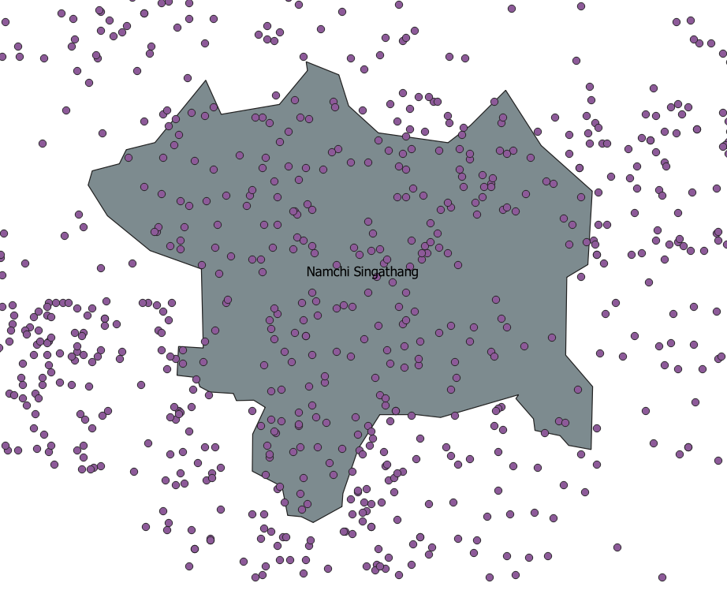

**Fig 3.5.** Plotting of coordinates on the study area for detecting outlier.

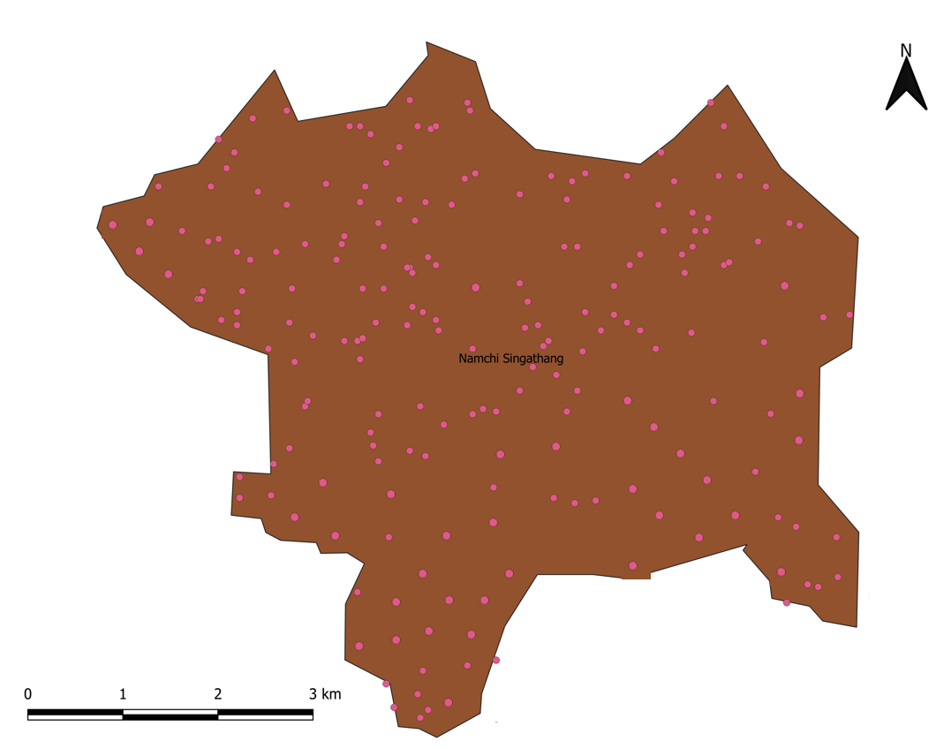

LEGEND

Sampling points

**Fig 3.6.** Plotting of coordinates (sampling points) on the study area after removing outlier.

1. **Georeferencing of study area map:**

Map of study area was georeferenced by taking its coordinate from the open street map of QGIS.

1. **Generation of vector layer:**

Georeferenced map of study area was digitized and a vector layer of the study area is generated.

1. **Interpolation of each nutrient’s data:**

Each nutrient data with its coordinate were interpolated using Ordinary Kriging method of interpolation in GIS. Interpolation is done with each nutrient data with its coordinate. After interpolation, interpolated raster data of each nutrient is clipped with the vector mask layer of study area. Distribution map of each nutrient is generated.

1. **Reclassification of each nutrient map:**

Each distribution map is reclassified with their Parker’s nutrient classes and new distribution map is generated which shows the distribution of each nutrient with its

Parker’s nutrient class on the map.

1. **Interpretation of maps:**

Interpretation of final map for analyzing the Parker’s nutrient index of each nutrient. Which shows the overall result of the content of each nutrient in the study area with three classes i.e. high, low and medium.

Chapter 4

**COST ESTIMATION**

**4.1. Approach and Method**

Costly of technical estimation should never be an activity that is performed independently of technical work. In the early life cycle phases, cost estimation is closely related to design activities, where the interaction between these activities is iterated many times as part of doing design trade studies and early risk analysis. Later o I the life-cycle, cost estimation supports management activities- primary detailed planning, scheduling and risk management. The purpose of software cost estimate is to.

1. Define the resources needed to produce, verify and validate the software product, and manage these activities.
2. Quality, in so far is practical, the uncertainty and risk inherent in this estimate.

**4.2. Cost Factor**

We should have to keep in mind that there are many factors that influences the of the product. The effect of tis factors, and hence the cost of the development or maintenance effort, are individual abilities of project personal and their familiarity with the application area the complexity of the product, the size of the product, the available time, the required level of reliability, the level of technology utilized and the

Availability, familiarity, and stability of the system used development the product.

The major factors that influence the software cost are as follows:

1. Programmer ability
2. Programmer complexity
3. Product size
4. Required reliability
5. Level of Technology
   1. **Cost Estimation Technique**
      1. **COCOMO Model**

The software cost estimation model this report will focus on is the Constructive Cost Model, as known as COCOMO. It was developed in 1981 by Barry Boehm proposed three levels of the model; basic, intermediate, detailed. We have chosen to use the intermediate level for our cost estimation model. The basic steps to determine the cost are:

1. Obtain an initial estimate of development effort the estimate thousands of lines of source code (KLOC).
2. Determine a set of A 15 multiplying factors from different attributes of the project.
3. Adjust the effort estimate with all the Multiplying factors.

The value of constants A and B depends on the project type. In this model, the projects are categorized into three modes- organic, semidetached and embedded.

Organic Model: This mode is usually carried out in house by developer teams that are familiar with application domain.

Embedded Model: Combination of organic and embedded modes.

Table 4.1 Rating

|  |  |  |
| --- | --- | --- |
| System | A | B |
| Organic | 3.2 | 1.05 |
| Semidetached | 3.0 | 1.12 |
| Embedded | 2.8 | 1.2 |

So, according to this our project falls under the category of organic.

A = 3.2

B = 1.05

Size (KLOC) = 700 approx.

Ei = 3.2 x (KLOC)

1.05

=3.2 x (.700)

1.05

=2.24

From the requirements, the rating of different cost driver attributes assessed.

These ratings are:

Table 4.2 Rating of Attributes Table 4.2 Rating Of Attributes

|  |  |  |
| --- | --- | --- |
| Complexity | High | 1.1 |
| Storage | High | 1.06 |
| Experience | Low | 1.13 |
| Programmer Capability | Normal | 1.17 |

Multiplying Factor, EAF = 1.1 x 1.06 x 1.13 x 1.17

=1.54

E = EAF x Ei

= 1.54 x 2.24

= 3.4 PM

D = 3.4 x (2.95)

0.38

=7.6 M

=8.0 M (approx..)

Where,

D is the development time in month

E is the effort applied by person in month

PM is persons / M is month

**Person Required:**

The amount of manpower involved = 3P x 5.0M

=15

M = 15 PM/5M

M = 3P

Therefore, the successful completion it will require 5 months and 4 persons.

Let us assume the total amount to be paid to an individual programmer is Rs. 15,000

So, the total amount to be paid for one month = 15,000/5

= Rs. 3,000

Total duration of project is 5 months. So, for completion of the project each individual programmer would get = Rs. 5,000 x 3

= Rs .15,000

Since, 3 programmers are in the project

Therefore, total cost the project would be = Rs. 15,000 x 3

= Rs. 45,000

CHAPTER 5

**APPLICATION**

**The Applications of Soil Fertility Mapping using GIS and Remote Sensing in Namchi Singithang are:**

Tis project is applicable in the field of agriculture to know the soil nutrients status of a particular region. By knowing the nutrient status of soils can be useful for farmers to improve their soil’s fertility by applying different methods on soil to increase the soil fertility and farmer can grow crop according fertility of their soil which is suitable for particular fertility level. Soil quality is equally import as that of crop production. Therefore, mapping of spatial variability of soil nutrients is important and significant, where soil fertility is the primary source of agriculture.

CHAPTER 6

**ANALYSIS AND RESULT**

Analysis and mapping work is done as per the steps defined in design and development chapter. Interpolation of preprocessed data of each nutrient of study area is done in the QGIS software by using ordinary kriging interpolation method and the interpolated output is clipped with its georeferenced study area boundary vector layer and a final map is generated which is the distribution map of each nutrient.

6.1. Interpolation of data using Ordinary Kriging method:

With exact nutrient value of each sampling coordinate (latitude and longitude) location of study area, nutrient content of other location within study area were predicted using ordinary kriging method of interpolation in QGIS. Distribution map of predicted value of each nutrient are generated (shown in figures: 6.1, 6.3, 6.5, 6.7, 6.9, 6.11, 6.13. 6.15, 6.17 and 6.19) with their graph representing the predicted value of pixel within study area and their frequency. X-axis shows the nutrient value within study area and Y-axis shows its frequency (shown in figures: 6.2, 6.4, 6.6, 6.8, 6.10, 6.12, 6.14. 6.16, 6.18 and 6.20).

**6.1.1. Analyzed outputs after interpolation and clipping:**

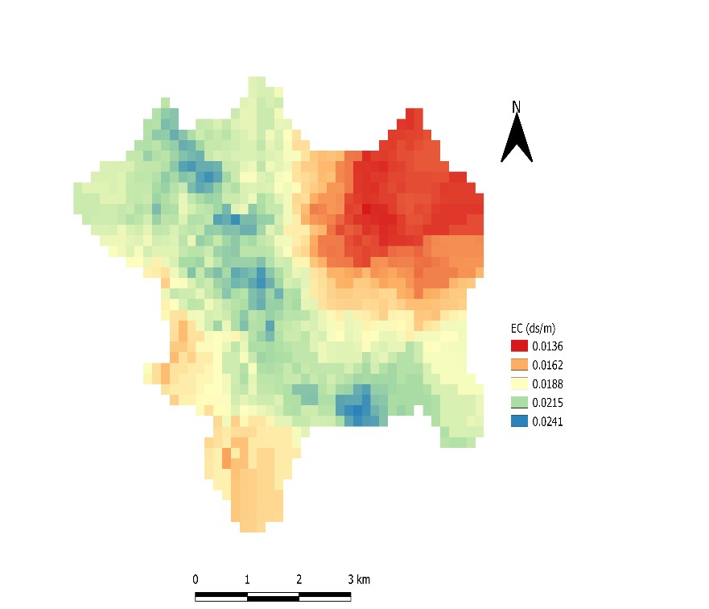**Fig 6.1.** Distribution of Electrical Conductivity(EC)

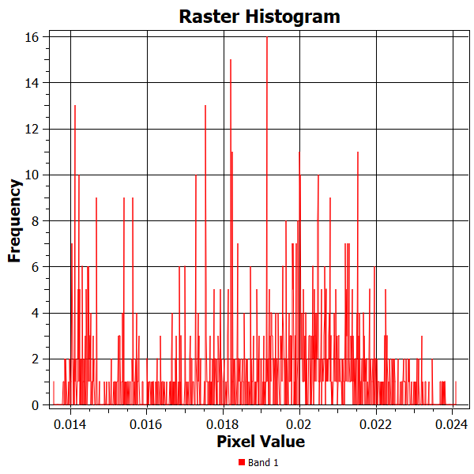

**Fig 6.2.** pixel value of EC distribution map with its frequency

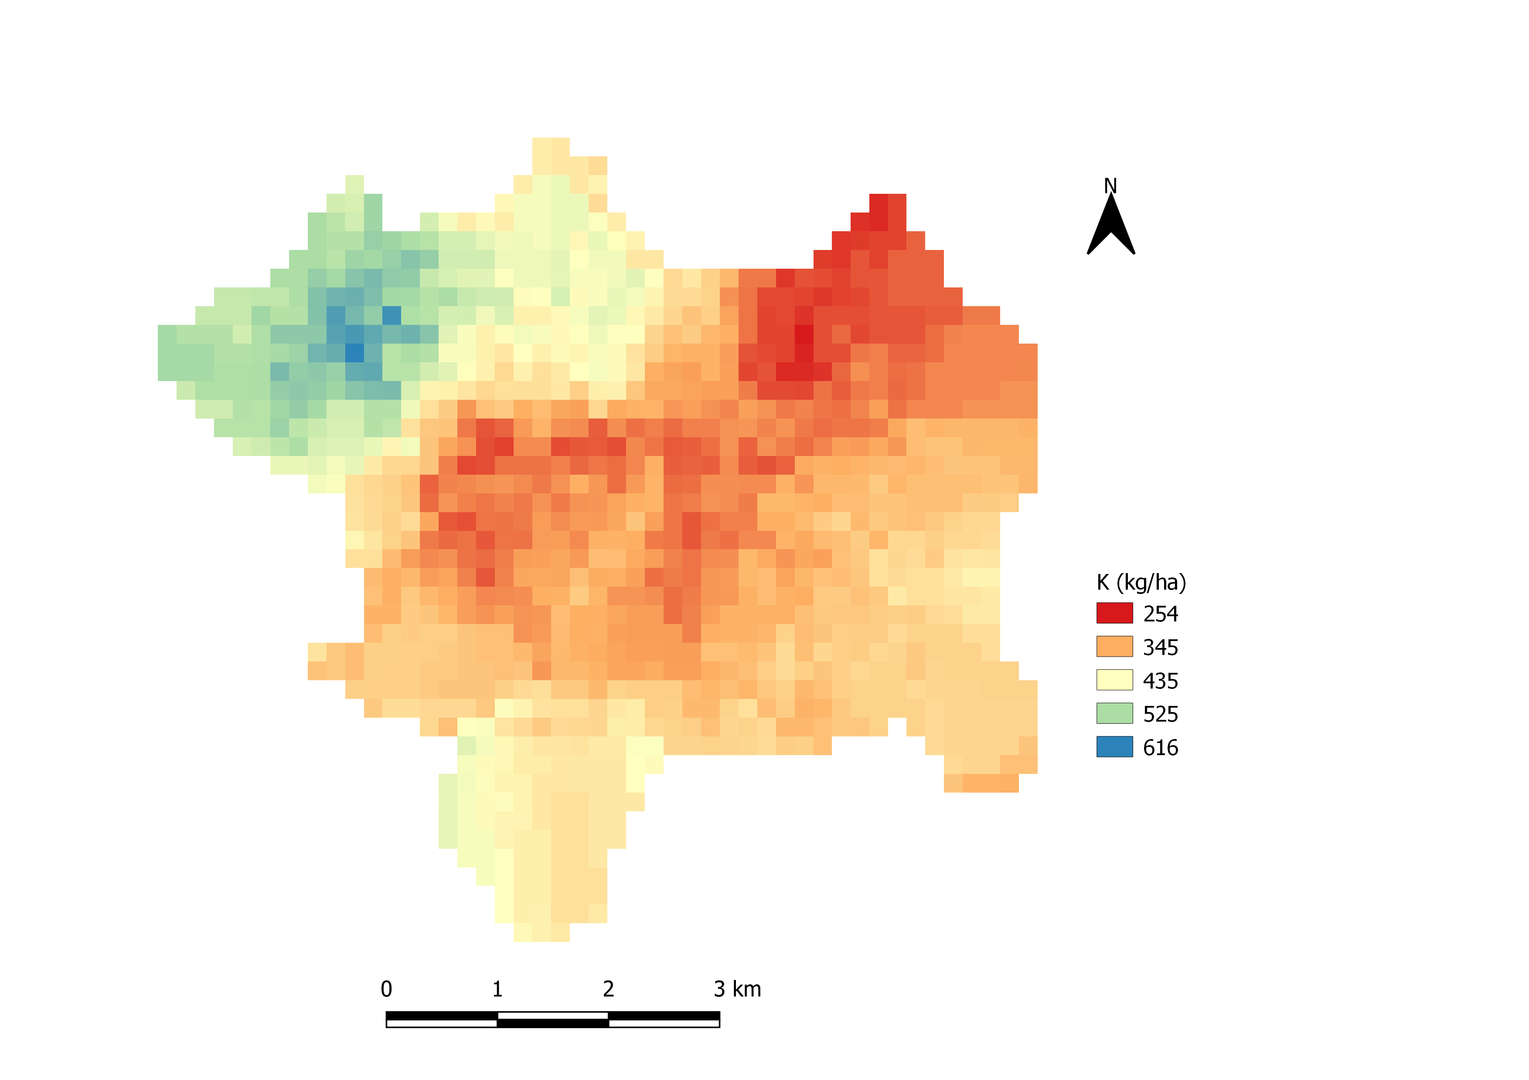

**Fig 6.3.** Distribution of Potassium(K)

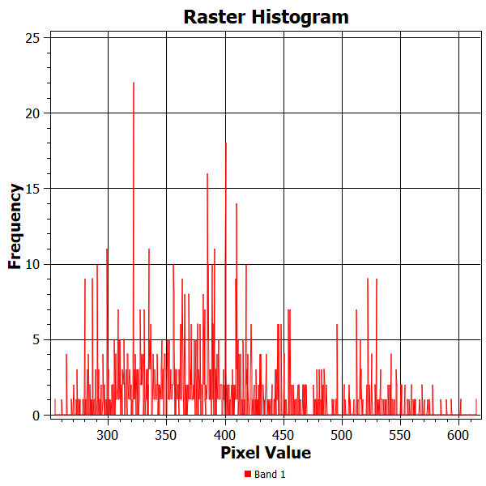

**Fig 6.4.** pixel value of K distribution map with its frequency

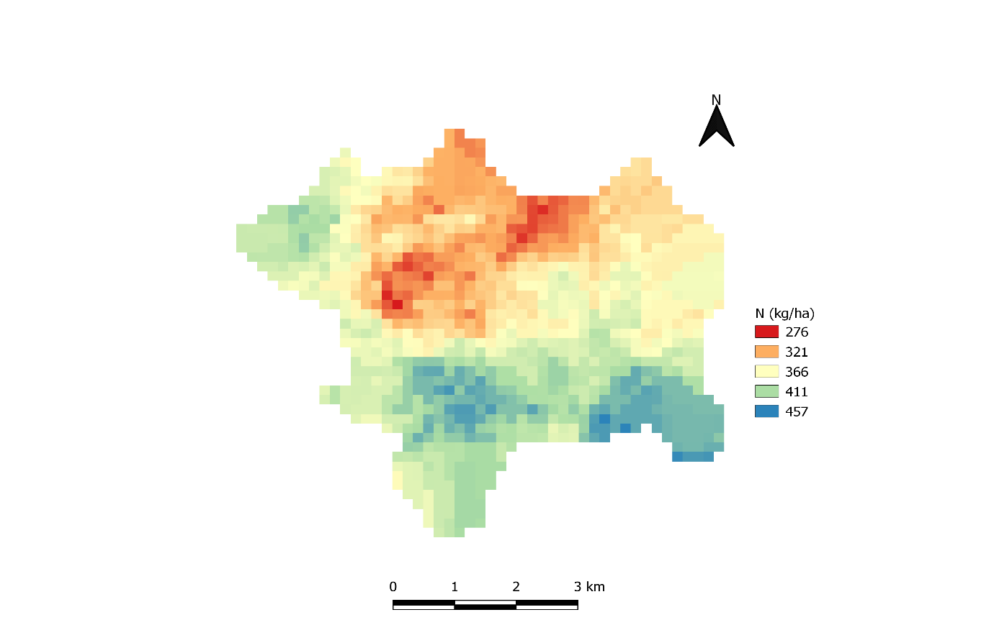

**Fig 6.5.** Distribution of Nitrogen(N)

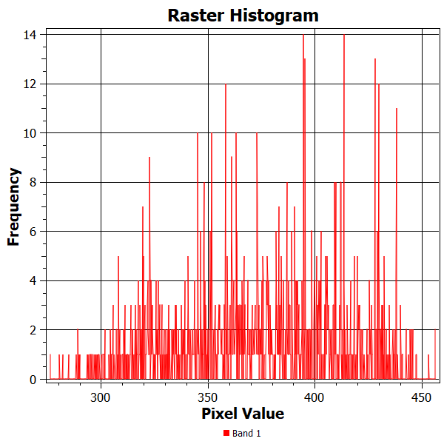

**Fig 6.6.** pixel value of N distribution map with its frequency

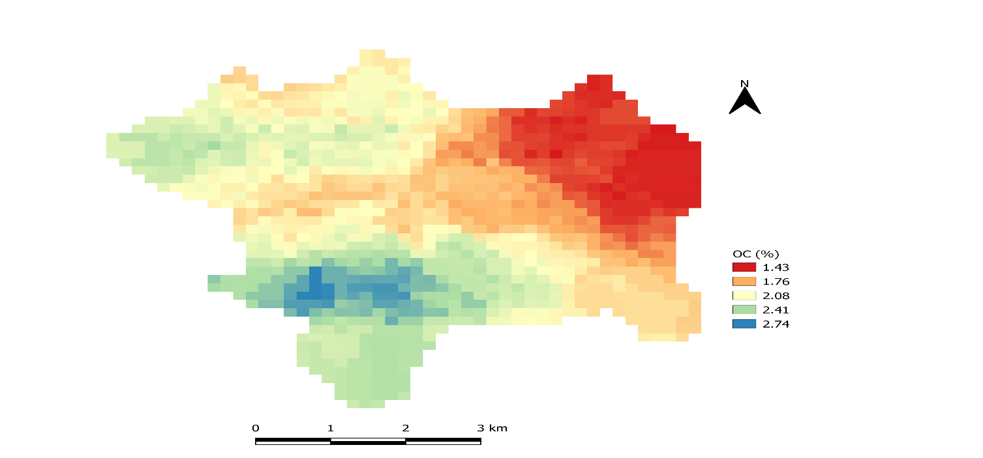

**Fig 6.7.** Distribution of Organic Carbon (OC)

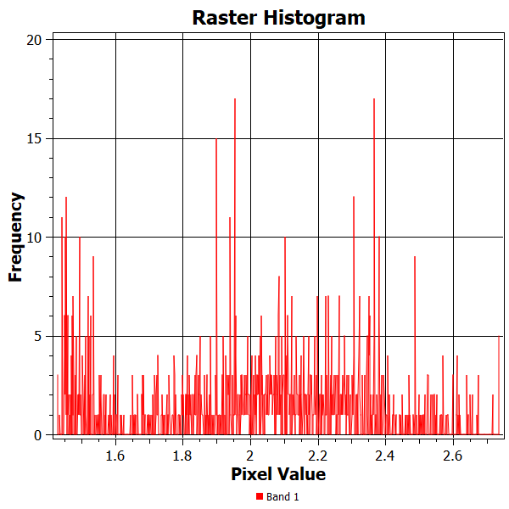

**Fig 6.8.** pixel value of OC distribution map with its frequency

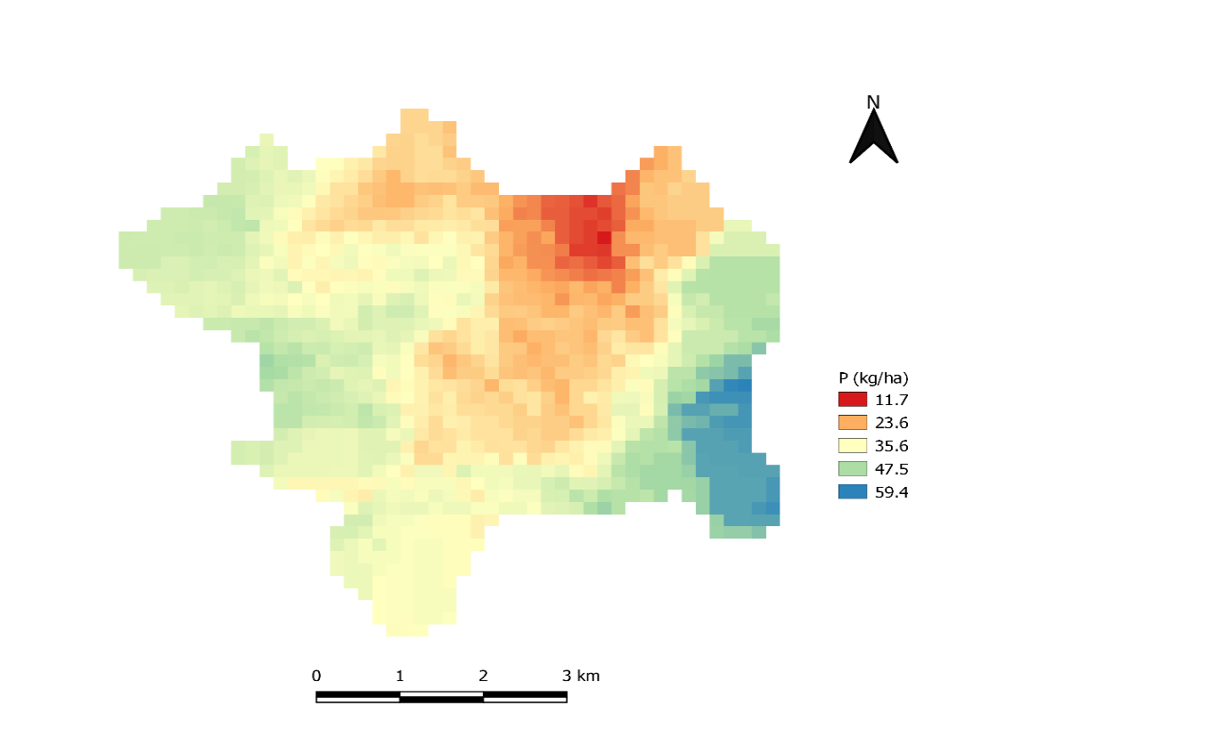

**Fig 6.9.** Distribution of Phosphorous (P)

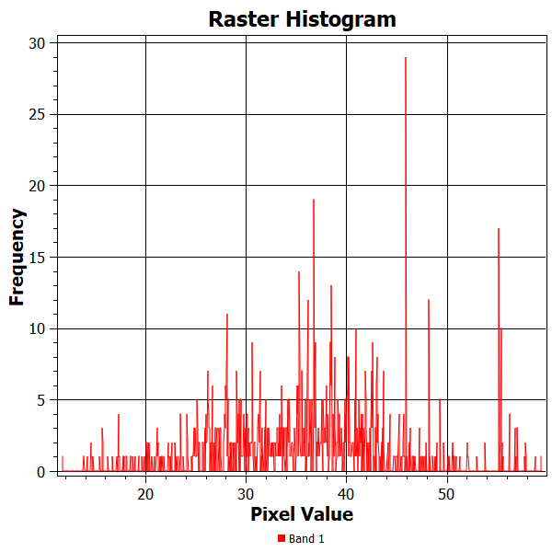

Fig 5.9: pixel value phosphorus (P) in respect with its frequency

**Fig 6.10.** pixel value of P distribution map with its frequency

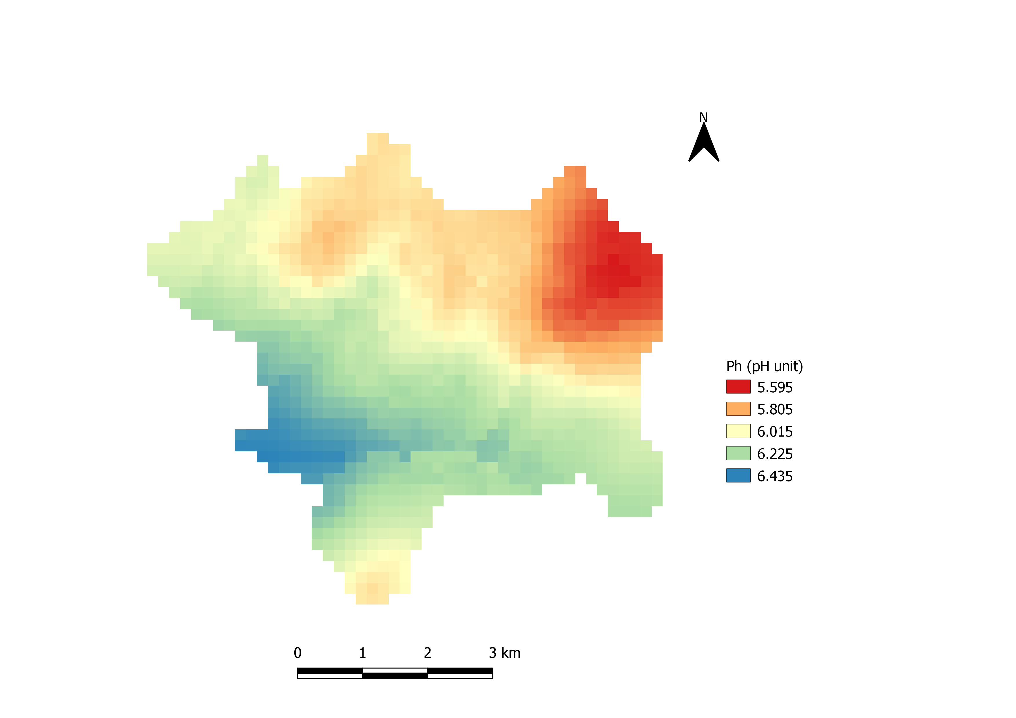

Fig 5.10: Distribution map of Potential of Hydrogen(Ph)

**Fig 6.11.** Distribution of Ph

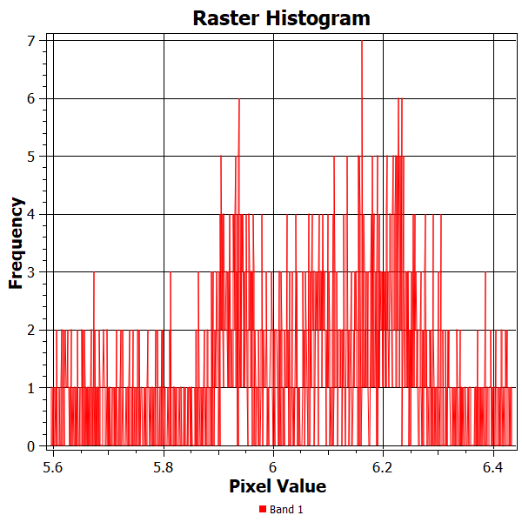

**Fig 6.12.** pixel value of Ph distribution map with its frequency

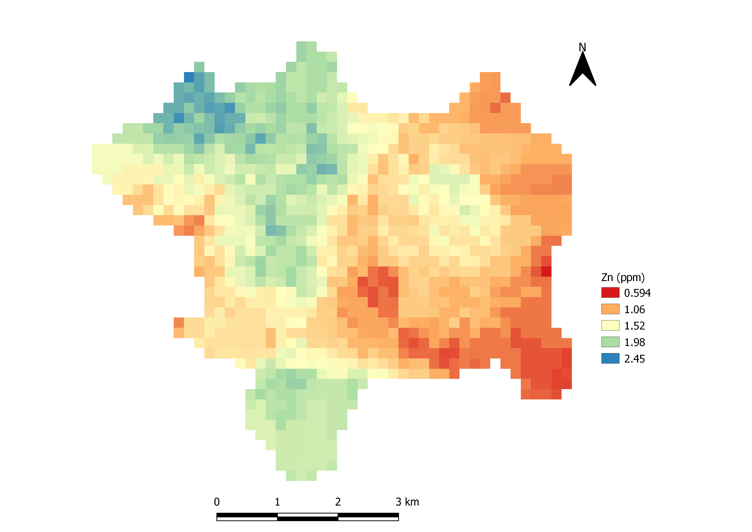

**Fig 6.13.** Distribution of Zinc (Zn)

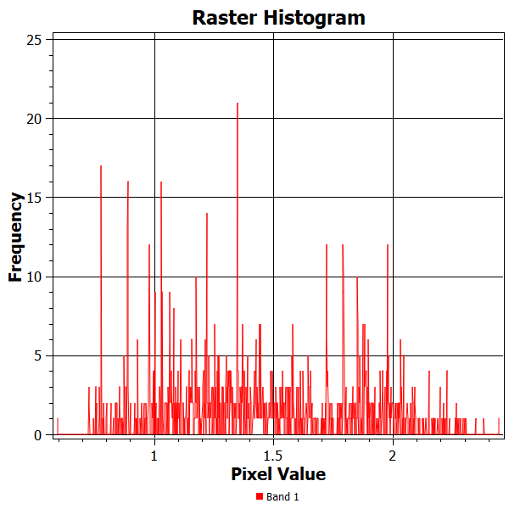

**Fig 6.14.** pixel value of Zn distribution map with its frequency

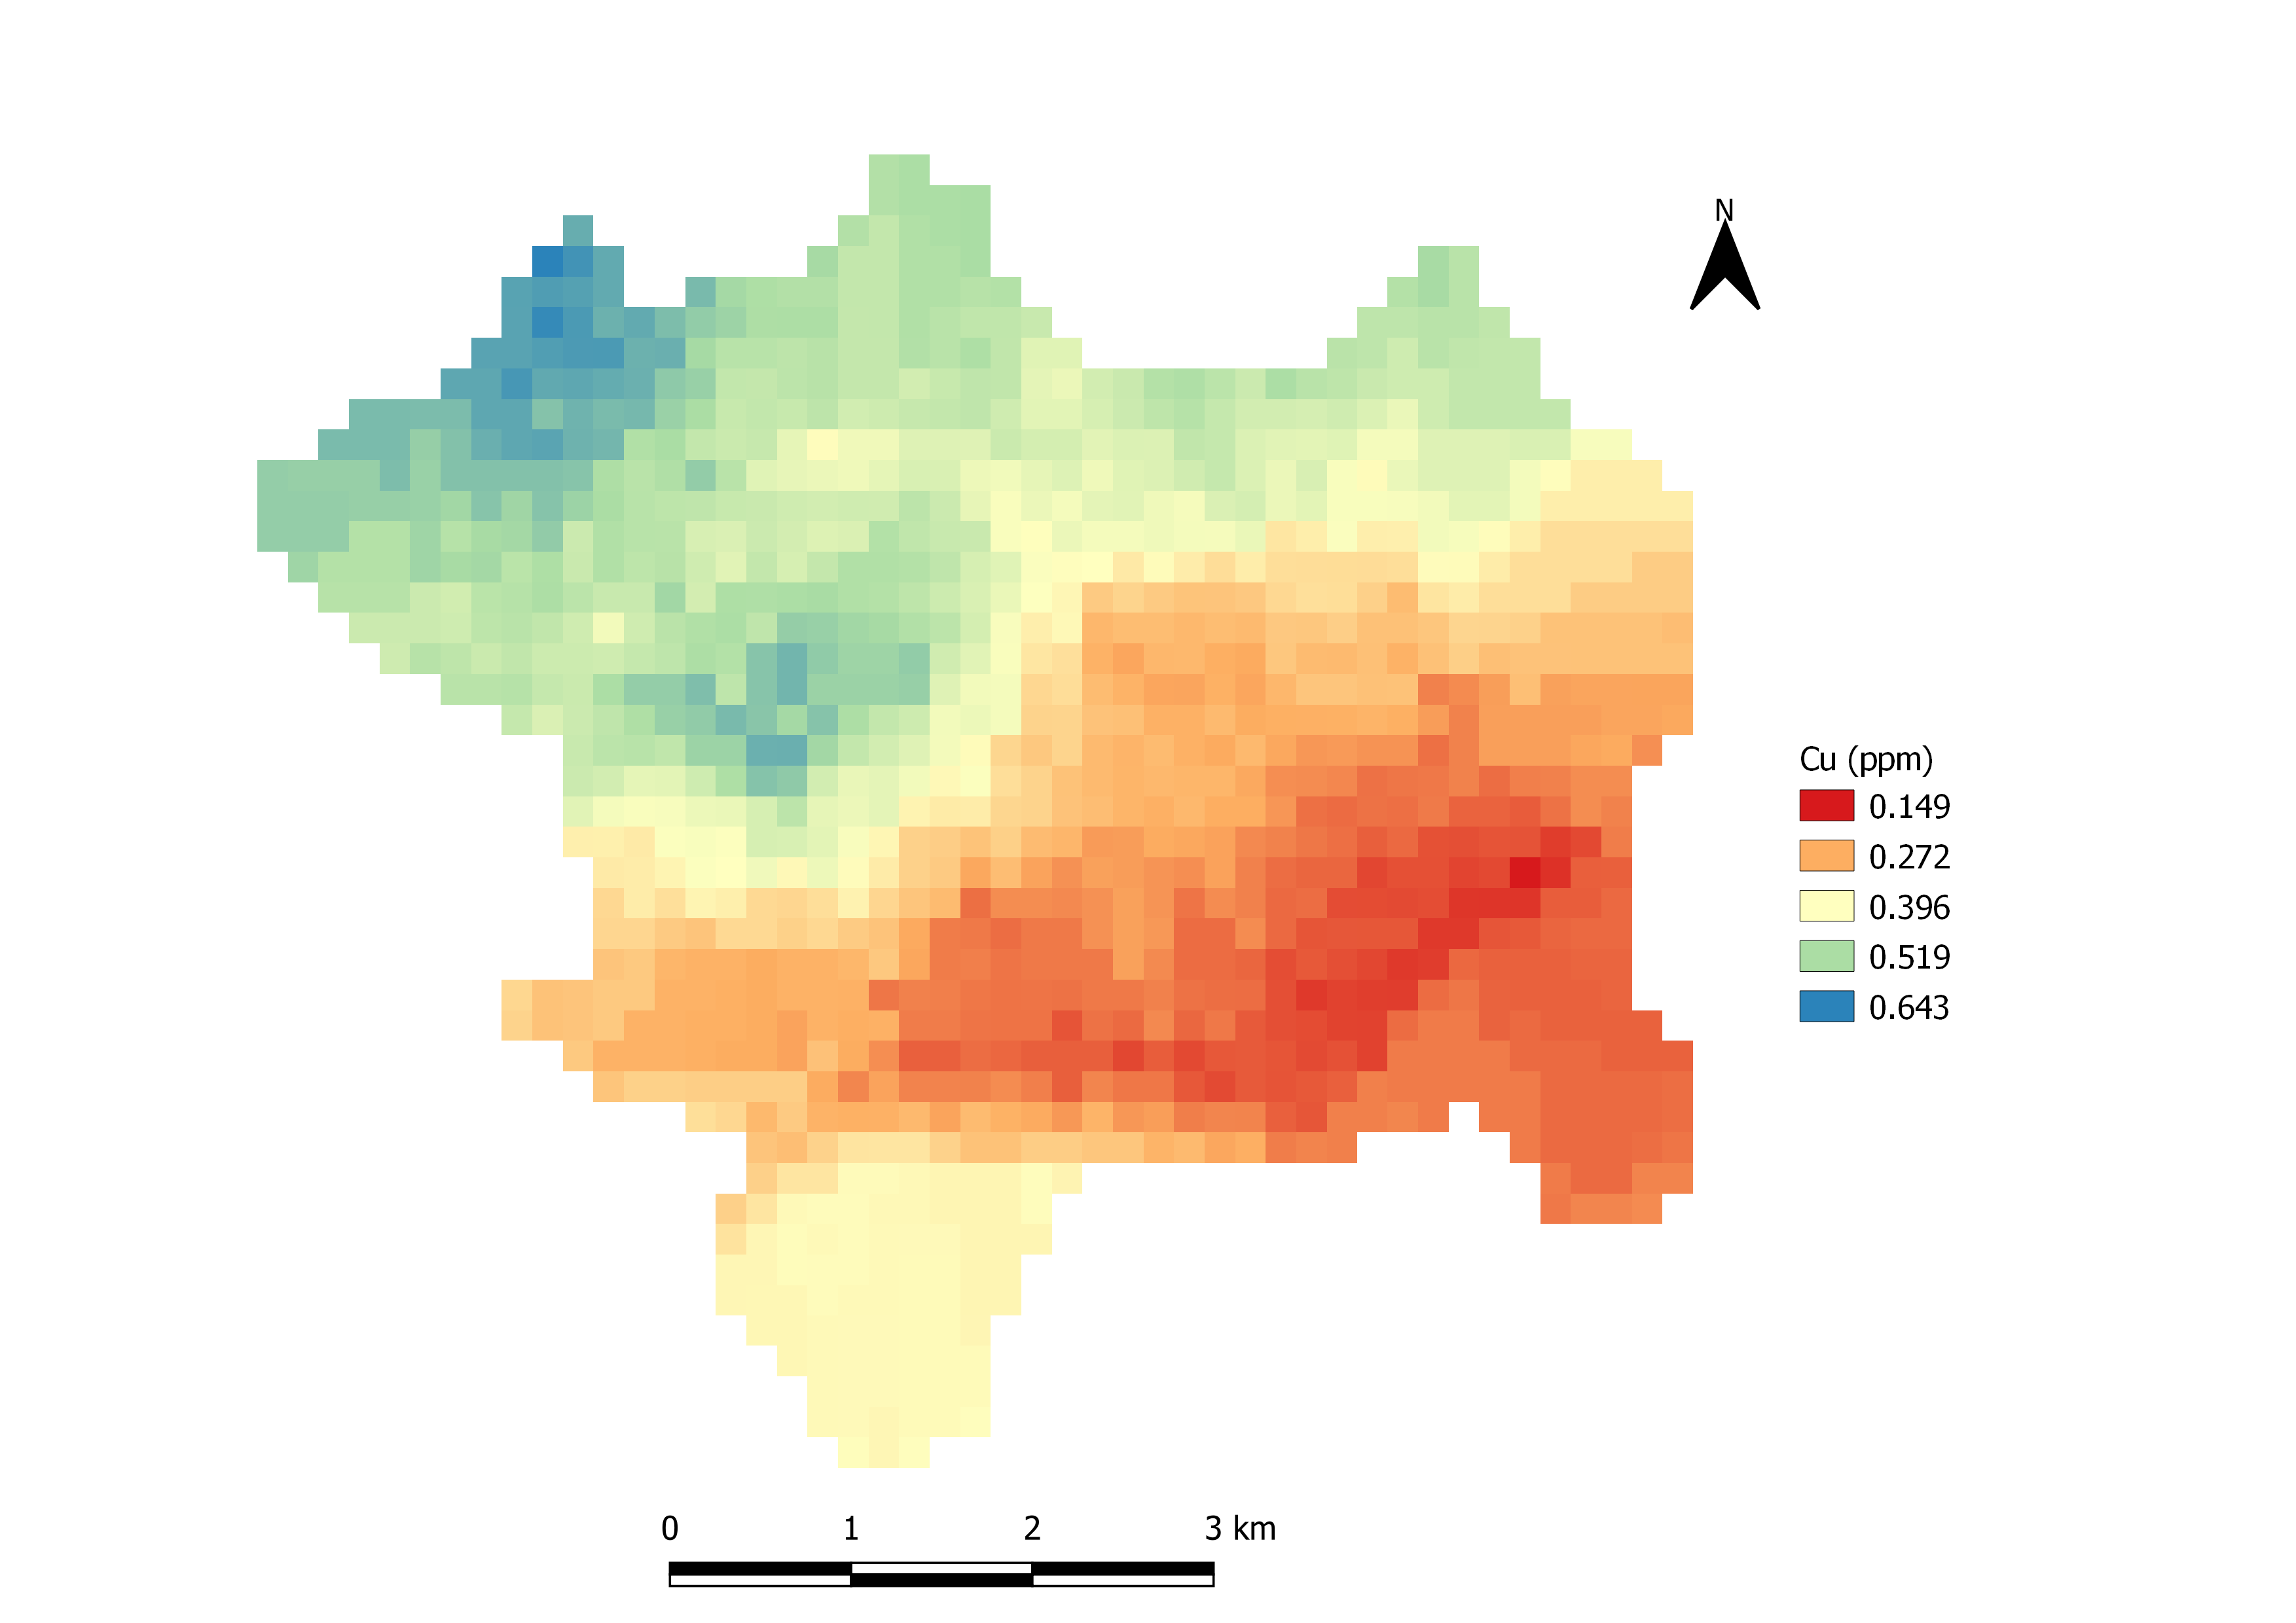

**Fig 6.15.** Distribution of Copper (Cu)

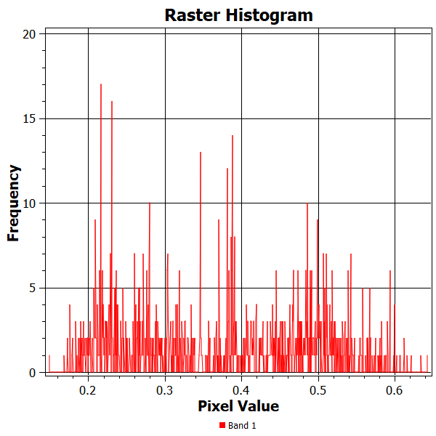

**Fig 6.16.** pixel value of Cu distribution map with its frequency

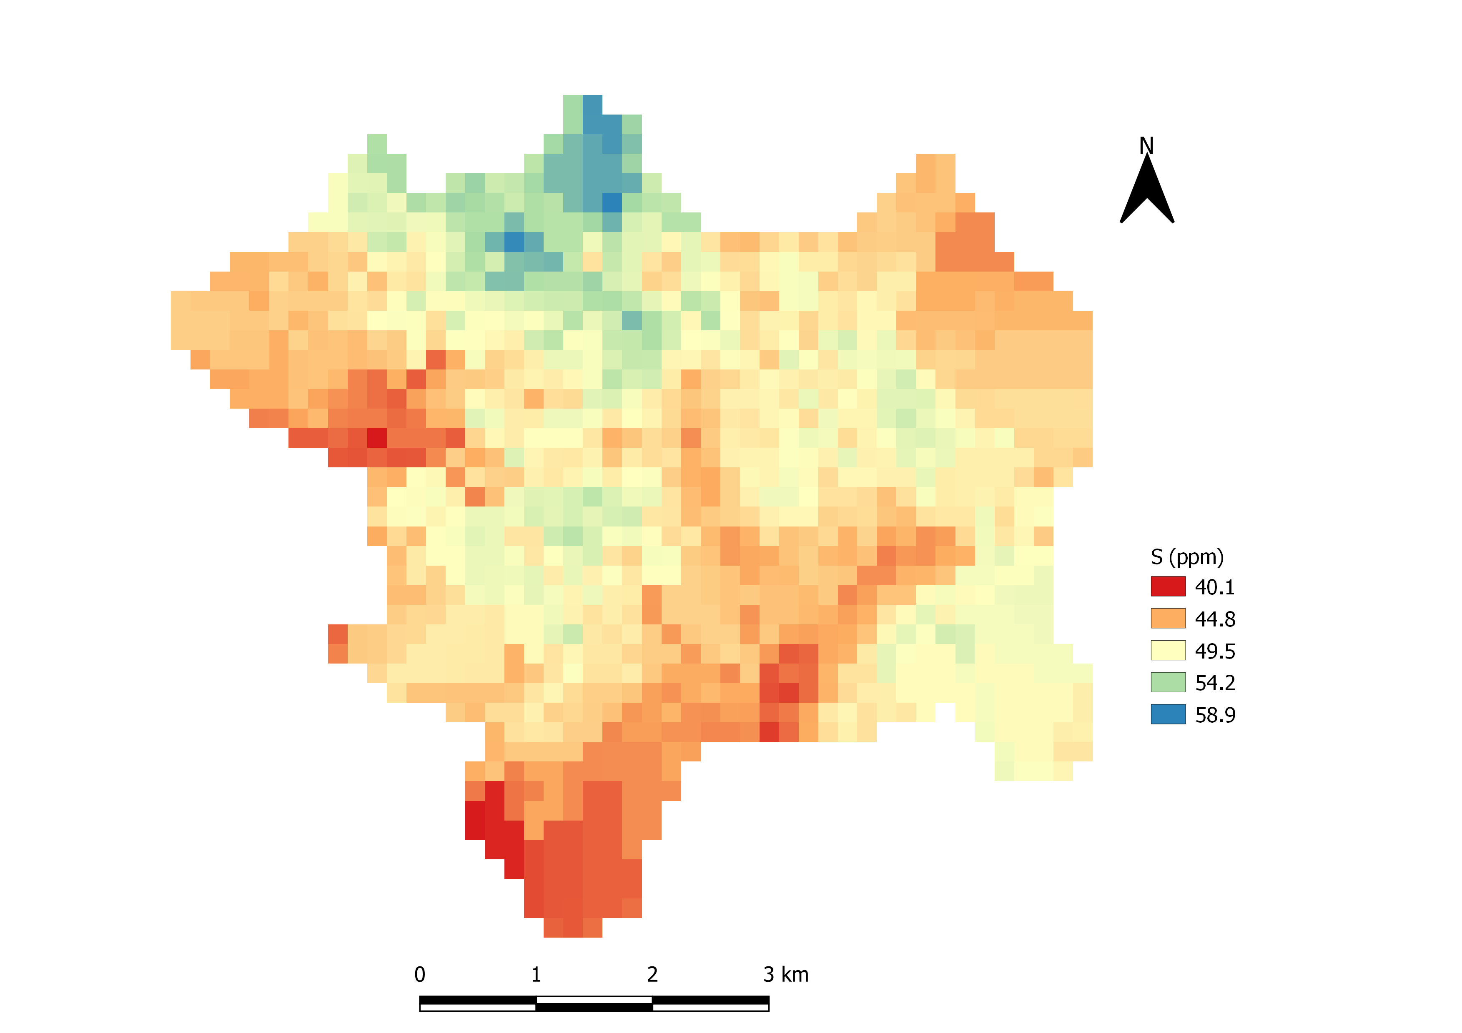

**Fig 6.17.** Distribution of Sulphur (S)

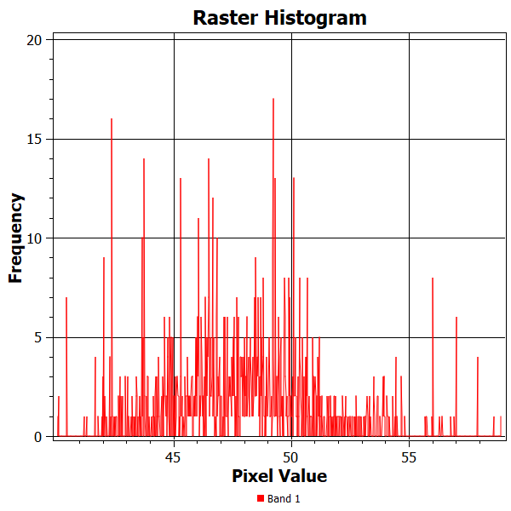

**Fig 6.18.** pixel value of S distribution map with its frequency

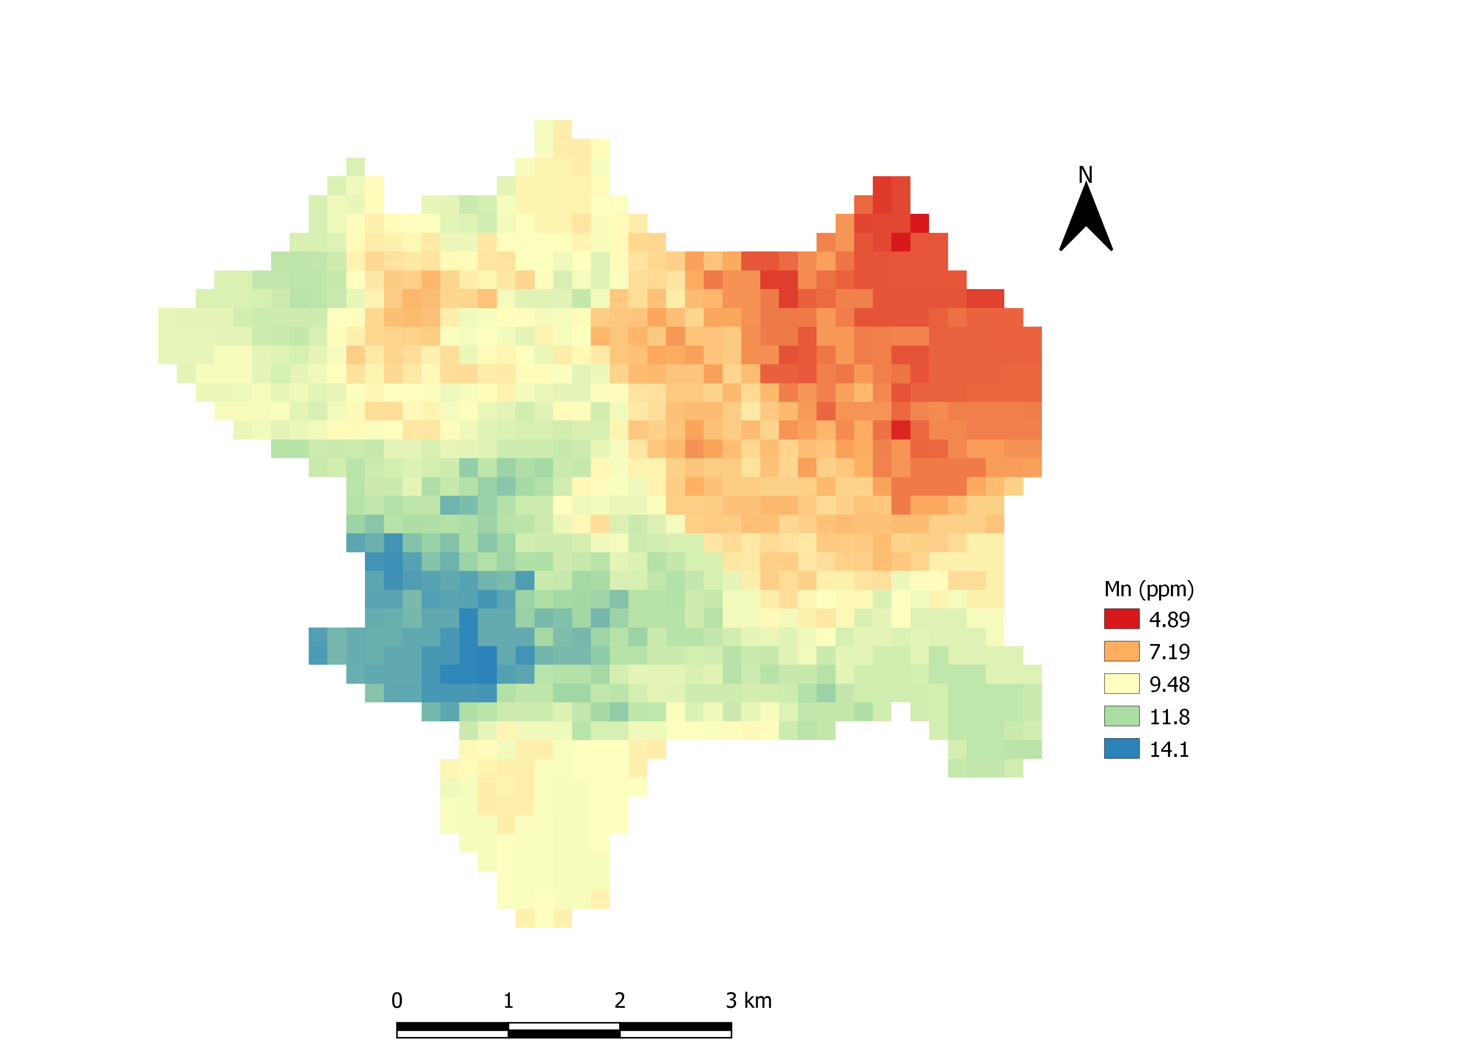

**Fig 6.19.** Distribution of Manganese (Mn)

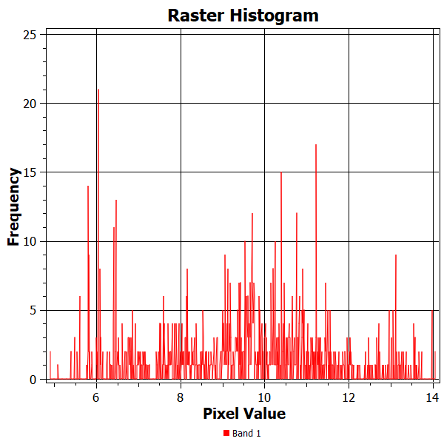

**Fig 6.20.** pixel value of Mn distribution map with its frequency

6.2. Reclassification of the map:

Each nutrient map is reclassified in QGIS by replacing certain range of nutrient value with its corresponding nutrient class i.e. class 1, class 2 and class 3 using Parker’s nutrient class (shown in table 1.1.). Reclassified map of each nutrient is shown in figures: 6.21, 6.22, 6.23, 6.24, 6.25, 6.26, 6.27, 6.28, 6.29 and 6.30 and classes and its corresponding ranges.

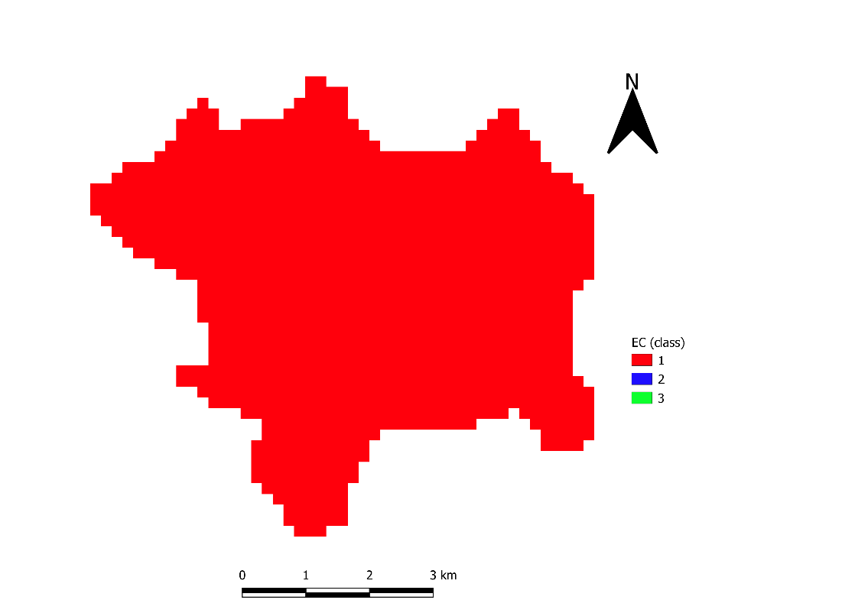

**Fig 6.21.** Reclassified map of EC

Class 1 represents EC value <1.0 (Normal)

Class 2 represents EC value 1.0-2.0 (Critical)

Class 1 represents EC >2.0 (Injurious)

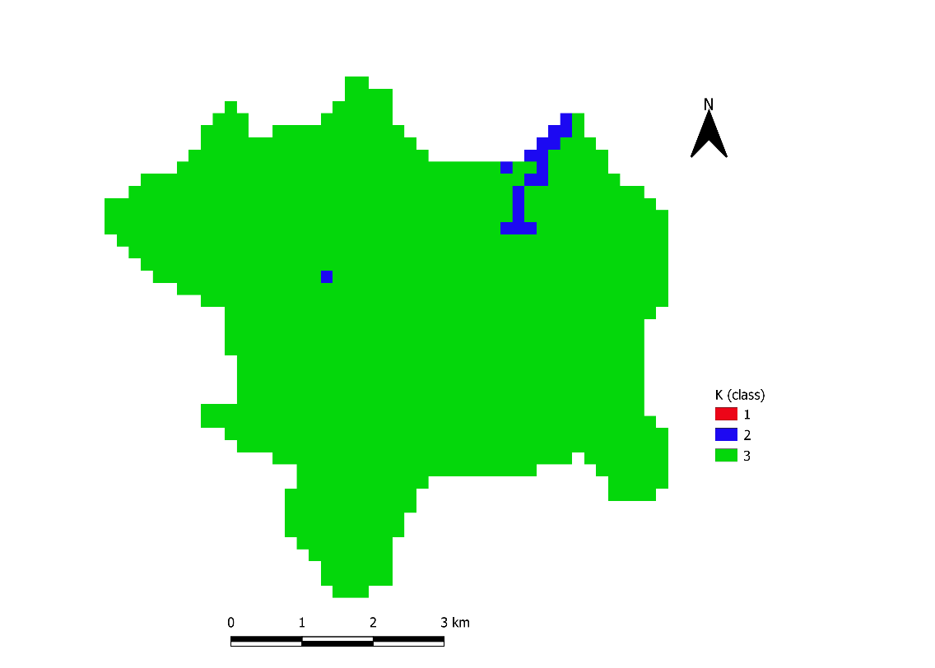

**Fig 6.22.** Reclassified map of K

Class 1 represents K value <110(Low)

Class 2 represents K value 110-280(Medium)

Class 1 represents k >280(High)

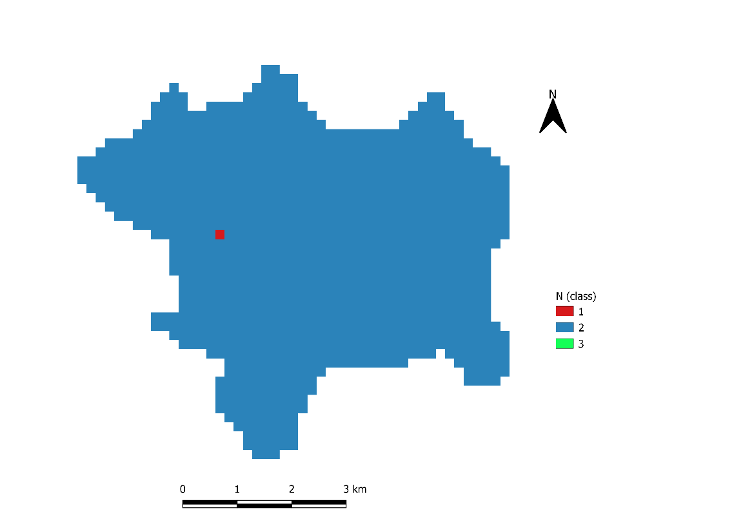

**Fig 6.23.** Reclassified map of nitrogen

Class 1 represents nitrogen value <280(Low)

Class 2 represents nitrogen value 280-560(Medium)

Class 1 represents nitrogen>560(High)

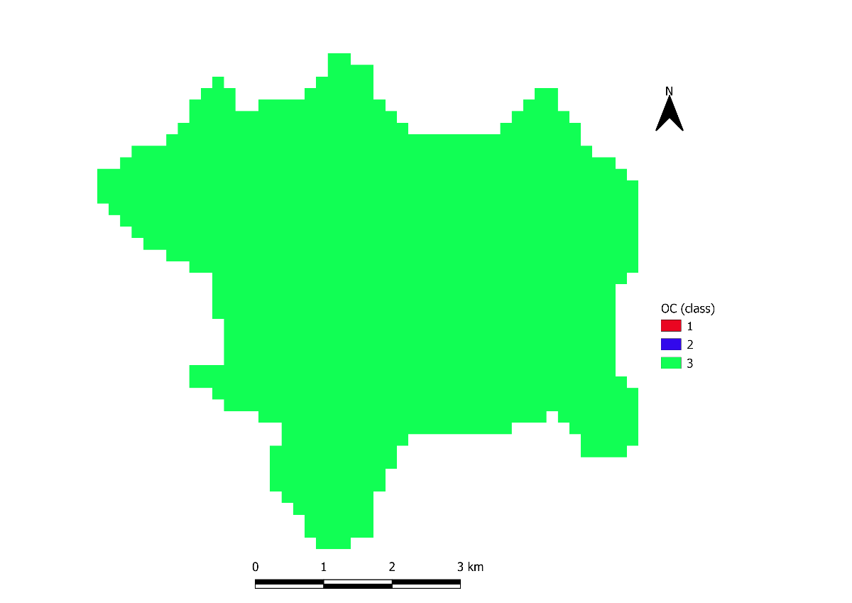

**Fig 6.24.** Reclassified map of OC

Class 1 represents OC value <0.5(Low)

Class 2 represents OC value 0.5-0.75(Medium)

Class 1 represents OC>>0.75(High)

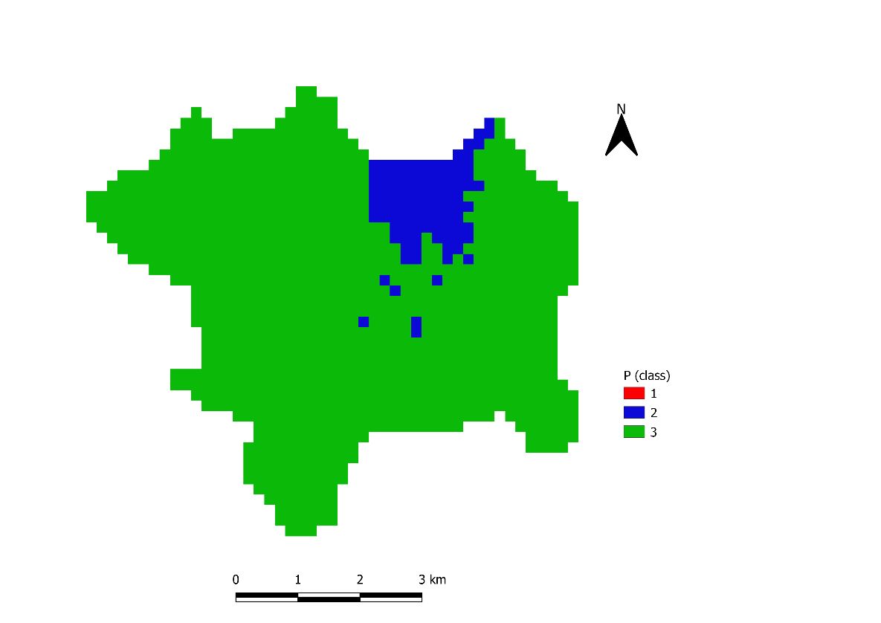

**Fig 6.25.** Reclassified map of phosphorus(P)

Class 1 represents P value <10(Low)

Class 2 represents P value 10-25(Medium)

Class 1 represents P>25(High)

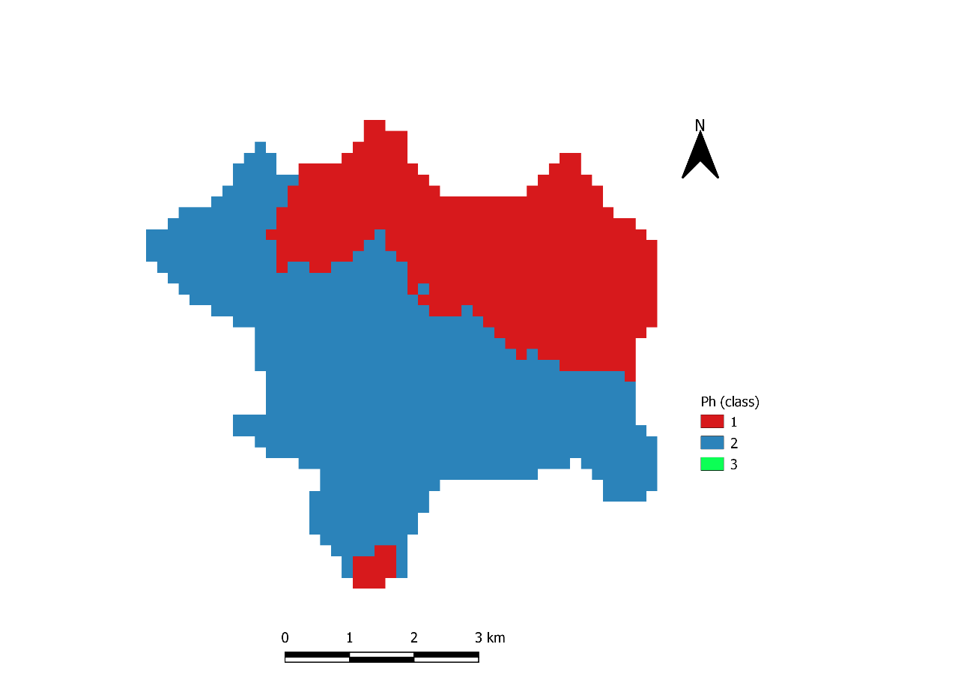

**Fig 6.26.** Reclassified map of photon hydrogen (Ph)

Class 1 represents Ph. value <6.o(Acidic)

Class 2 represents Ph. value 6.1-8.0(Neutral)

Class 1 represents Ph.>25>8.0(Alkaline)

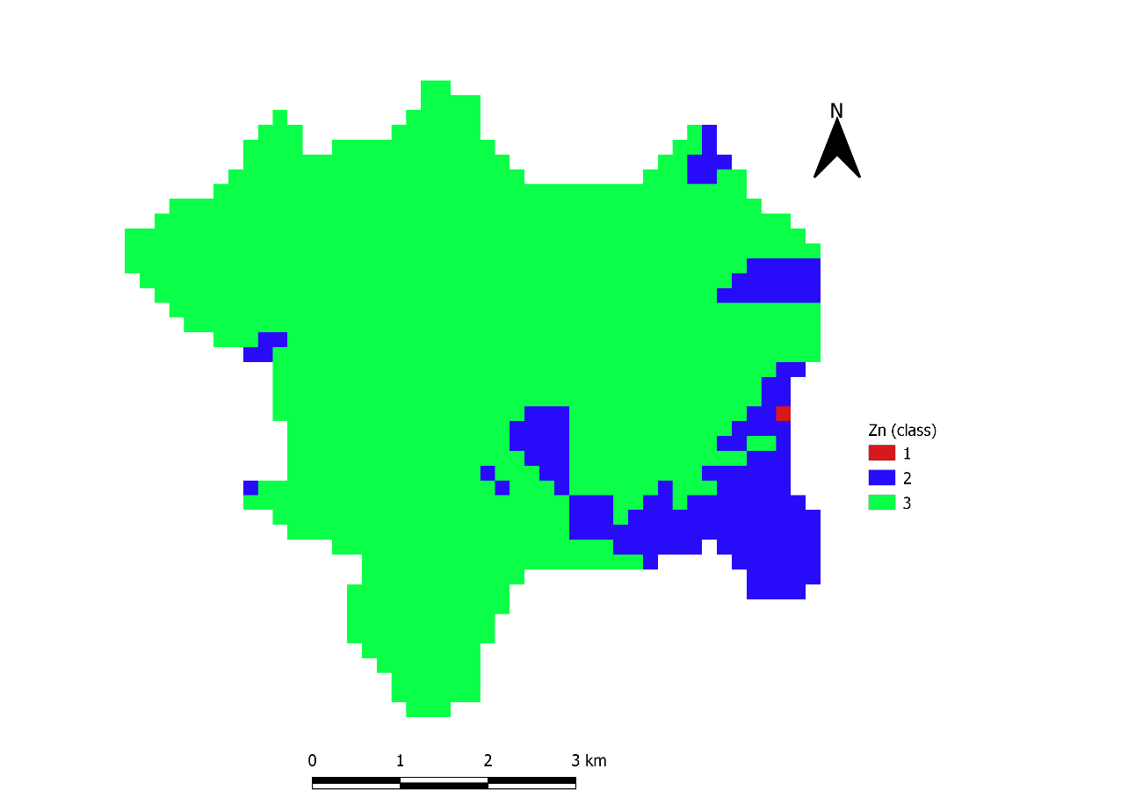

**Fig 6.27.** Reclassified map of Zinc (Zn)

Class 1 represents Zn. value <0.6(Low)

Class 2 represents Zn. value 0.6-1.0(Medium)

Class 1 represents Zn. >1.0(High)

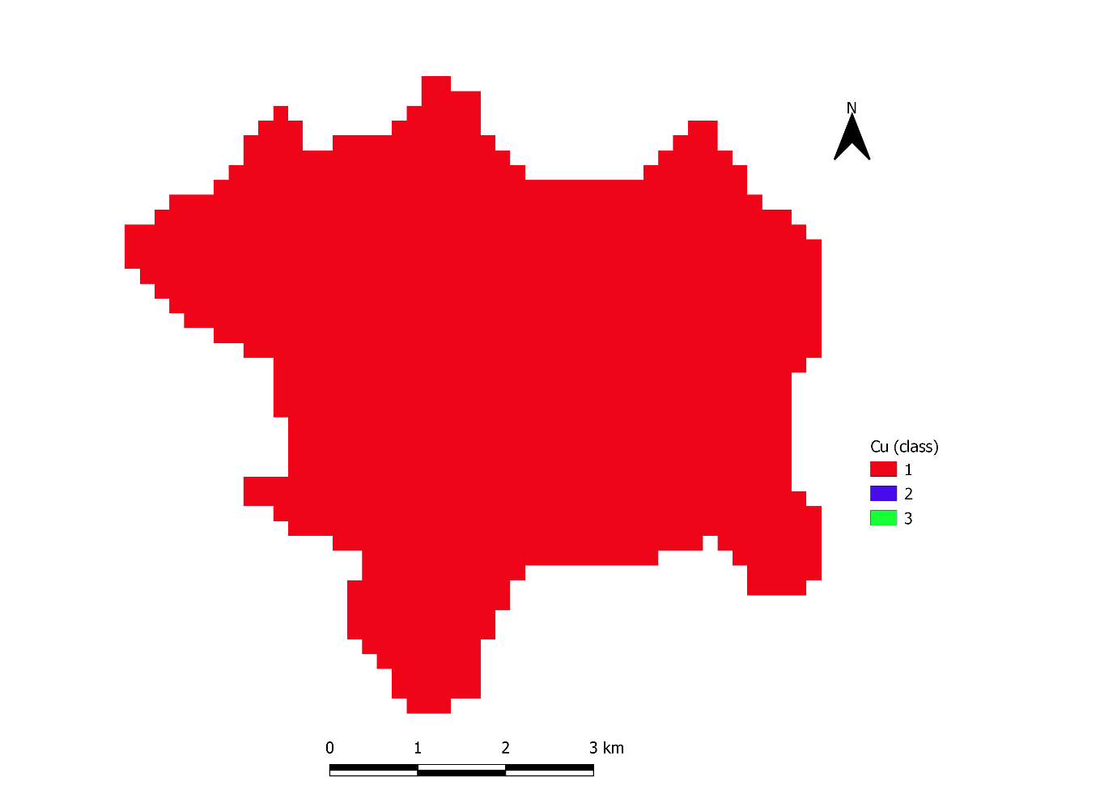

Class 1 represents Cu. value <4.5(Low)

Class 2 represents Cu. value 4.5-5.5(Medium)

Class 1 represents Cu. >>5.5(High)

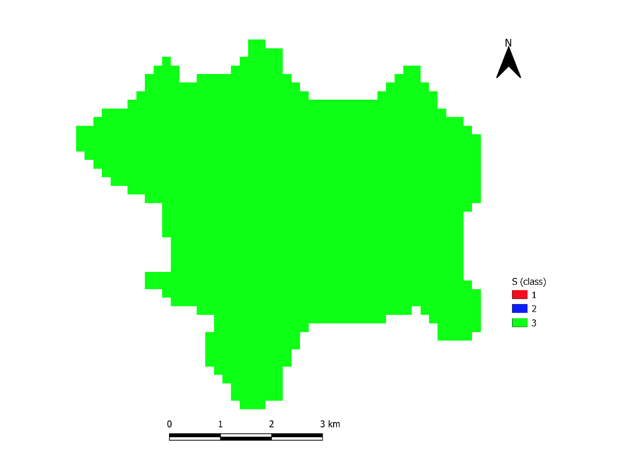

**Fig 6.29.** Reclassified map of Sulphur (S)

Class 1 represents S. value <10(Low)

Class 2 represents S value 10-30(Medium)

Class 1 represents S value >30(High)

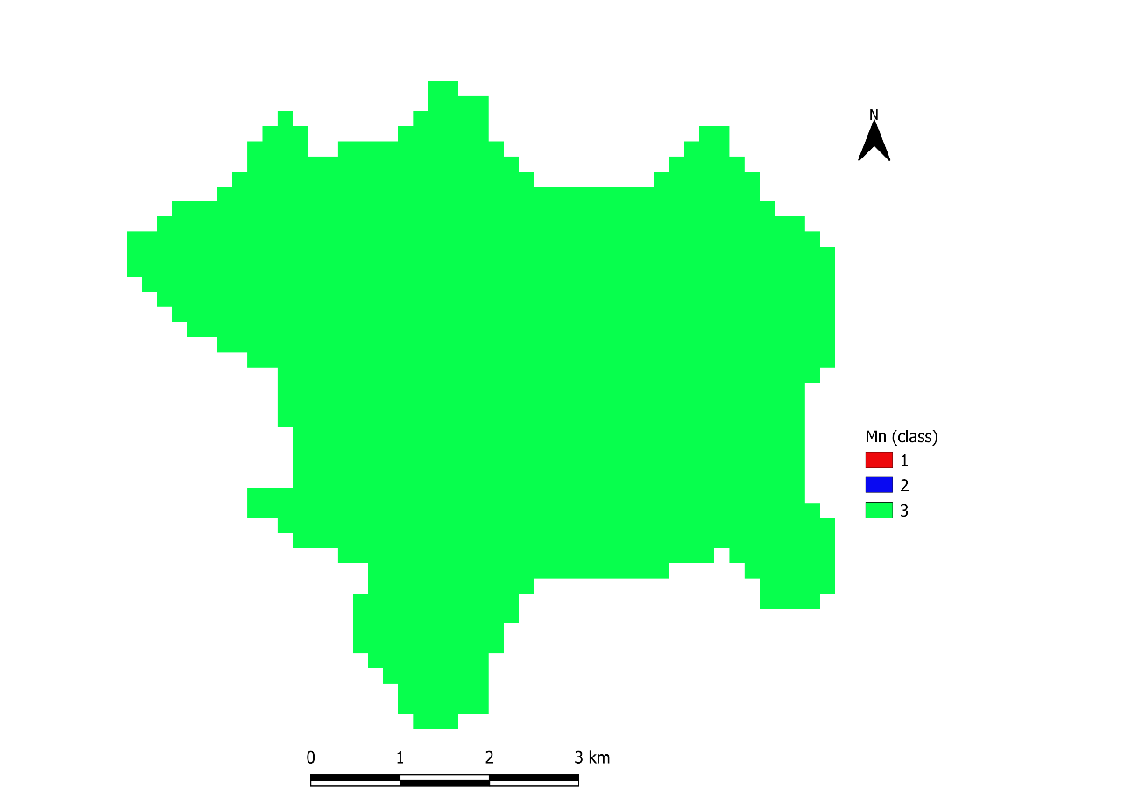

**Fig 6.30.** Reclassified map of manganese (Mn)

Class 1 represents Mn value <2.0(Low)

Class 2 represents Mn value 2-3(Medium)

Class 1 represents Mn value >3.0(High)

Chapter 7

CONCLUSION

The proposed system provides a digitally mapped Soil Fertility status of Namchi, Singithang, South Sikkim. This project is based on QGIS which is one of the open source platform of GIS. QGIS provides various tools and techniques for mapping. The data of soil from different farmers is collected from the Soil Health Card website, ICAR. This data is then digitally mapped with QGIS which then provides us with soil nutrient status of an exact location. This project will be very helpful in agricultural sector as with the proper information about the soil one can always have better crop production and also decrease the use of chemical fertilizer.

ACRONYMS

1. GIS: Geographic Information System
2. GPS: Global positioning System
3. QGIS: Quantum Geographic Information System
4. RS: Remote sensing
5. OK: Ordinary Kriging
6. OC: Organic Carbon
7. N: Nitrogen
8. P: Phosphorus

1. K: Potassium
2. Cu: Copper
3. Mn: Manganese
4. Fe: Iron
5. Zn: Zinc
6. P: Phosphorous
7. pH: Potential of Hydrogen
8. Ds/m: deciSiemens per meter
9. Kg/ha: kilogram per hectare
10. meg: monoethylene glycol
11. ppm: parts per million
12. SAGA(GIS): System for Automated Geoscientific Analysis
13. IDW: Inverse distance weighted
14. ICAR: Indian council of Agriculture Research
15. SHP: Shape File
16. TIFF: Tagged Image File Format
17. GRASS: Geographic Resources Analysis Support System

**REFERENCES**

[1] P K Kingra, Debjyoti Majumder and Som Pal Singh, “APPLICATION OF REMOTE SENSING AND GIS IN AGRICULTURE AND NATURAL RESOURCE MANAGEMENT UNDER CHANGING CLIMATIC CONDITIONS”, School of Climate Change and Agricultural MeteorologyPunjab Agricultural University, Ludhiana – 141 004.

[2] Anjali Kalidas Kadam, “GPS-GIS BASED SOIL FERTILITY MAP OF COLLEGE OF AGRICULTURE FARM, KARAD”, International Journal of Engineering Research and General Science, 2015.

[3] Ammannawar Prashant Babasaheb, “GPS-GIS BASED SOIL FERTILITY MAPS OF PATHARDI TEHSIL, DIST-AHMEDNAGAR”, department of soil science and agricultural chemistry, post graduate institute mahatma phule krishi vidhyapeeth rahuri-413 722 2015.

[4] “SOIL TAXONOMY A BASIC SYATEM OF SOIL CLASSIFICATION AND MAKING AND INTREPRETING SOIL SURVEYS”, Second Edition, 1999 By Soil Survey Staff, United States Department of Agriculture Agriculture Handbook Natural Resources Conservation Service Number 436.

[5] Swati Narsing Nandagawali, “PARAMETERS OF SOIL FERTILITY (As a Part of Project on Soil Parameters Monitoring with Automatic Irrigation System)”, Electronics and Telecommunications Department Government College of Engineering, Chandrapur, India, International Journal of Electrical and Electronics Research ISSN 2348-6988 (online) Vol. 3, Issue 4, pp: (219-222), Month: October - December 2015.

[6] “INTRODUCTION TO MAP AND ITS TYPES”, 1996 Environmental Systems Research Institute, Inc.

[7] Michael Flaxman, Joseph Ferreira, Thomas H. Grayson and Xiongjiu Liao, “SPATIAL DATA MODELS: SPATIAL ANALYSIS”, Massachusetts Institute of Technology Department of Urban Studies and Planning, march 13,2019.

[7] Andreas Hackeloeer, Klaas Klasing, Jukka M. Krisp & Liqiu Meng, “GEOREFERENCING: A REVIEW OF METHODS AND APPLICATION”, Annals of GIS.

[8] Mrs. K.R. Manjula, Dr. S. Jyothi and Mr. S. Anand Kumar Varma, “DIGITIZING THE FOREST RESOURCE MAP USING ARC GIS”, IJCSI International Journal of Computer Science Issues, Vol. 7, Issue 6, November 2010.

[9] Qulin Tan, Xiao Xu, “COMPARATIVE ANALYSIS OF SPATIAL INTERPOLATION METHODS: AN EXPERIMENTAL STUDY”, Photogrammetric Engineering & Remote Sensing, School of Civil Engineering, Beijing Jiaotong University, Beijing, China, Sensors & Transducers, Vol. 165, Issue 2, February 2014.

[10] Shruti Y, Praveen GS, Geetha GP, Sathish A, and Ramakrishna Parama VR, “ASSESSMENT OF SOIL NUTRIENTS AND RECOMMENDATION OF BALANCED FERTILIZERS FOR ENHANCING CROP PRODUCTIVITY USING REMOTE SENSING AND GIS”, Journal of Pharmacognosy and Phytochemistry, Department of Soil Science and Agricultural Chemistry, University of Agricultural Sciences, GKVK, Bangalore, Karnataka, India, 2017.

[11] Shishu Pal Singh, Shivraj Singh, Ashok Kumar and Rajesh Kumar, “SOIL FERTILITY EVALUATION FOR MICRONUTRIENTS USING PARKERS NUTRIENT INDEX APPROACH IN SOME SOILS OF VARANASI DISTRICT OF UTTAR PRADESH, INDIA”, International Journal of Pure & Applied Bioscience, 2018.

[12] Djeneba Dembele, “INTEGRATION OF REMOTE SENSING AND GEOGRAPHIC INFORMATION SYSTEM IN SOIL FERTILIY MANAGEMENT IN MALI”, Kwame Nkrumah University of Science and Technology (Knust), Kumasi, Ghana, School of Graduate Studies, Department of Crop and Soil Sciences, October 2015.

[13] Nahak Truptimayee, Mishra Antaryami, Saren Subhashis and Pogula S., “GPS AND GIS BASED SOIL FERTILITY MAPS OF RANITAL KVK FARM AND IDENTIFICATION OF SOIL RELATED PRODUCTION CONSTRAINTS”, International Journal of Agriculture Sciences, Department of Soil Science and Agricultural Chemistry, Orissa University of Agriculture and Technology, Bhubaneswar, 751003, Odisha, 2016.